Matric Number | 23111363
Name | Wang Shibo
Occurrence | 1
Supervisor Name | HANNYZZURA BINTI PAL AFFAL
WQD7025
DATA SCIENCE RESEARCH PROJECT
Prediction of Extreme Weather Events: Machine Learning Models Trained on Multivariate Meteorological Data
Session 2024/2025 Semester 2
Abstract
As global warming, the frequency and intensity of extreme weather events such as drought and flood have increased significantly, posing a serious threat to the safety of life and property across Asia. To enhance the ability to predict such events, this study proposes the hybrid CEEMDAN-LSTM and CEEMDAN-CNN-LSTM model that combines adaptive noise complete ensemble empirical mode decomposition (CEEMDAN), convolutional neural network (CNN) , and long short-term memory (LSTM) neural network for multivariate meteorological data-driven extreme weather forecasting.
The study selected monthly meteorological data from eight Asian countries from 1950 to 2023, including 15 important variables such as precipitation (pr), consecutive dry days (cdd), maximum daily precipitation (rx1day), and maximum temperature (tasmax). The modeling process follows the framework of "decomposition-reconstruction-prediction-integration": For the CEEMDAN-LSTM model, the process begins with CEEMDAN decomposing the target variable series into multiple Intrinsic Mode Functions (IMFs) at different time scales, extracting local features of the variable. Next, each IMF is individually predicted using LSTM. Then, the predicted values of all IMFs are summed at each time step to obtain the complete forecasted time series of the target variable. Finally, classify the result based on predefined thresholds, extreme weather labels (such as drought, flood) are generated. As for the CEEMDAN-CNN-LSTM model, after effective decomposition using CEEMDAN, CNN is applied to extract features from the meteorological data, uncovering the mapping relationships between different meteorological factors and the target variable series. This further reduces the dimensionality of the meteorological data and enhances the model’s feature learning capability. Subsequently, LSTM is used for prediction.
Compared with the traditional LSTM model, the performance evaluation of the CEEMDAN-LSTM and CEEMDAN-CNN-LSTM model show that they have better ability in predicting complex and non-stationary meteorological series. This study not only overcomes the existing technical limitations in the field of climate prediction, but also provides a scientific basis for the implementation of the United Nations Sustainable Development Goal 13 (climate action) and for the formulation of early warning systems and climate adaptation policies.
INTRODUCTION
Research Background
With the progress of global climate change such as global warming, long-term climate change has gradually led to the frequency of some extreme weather events becoming more and more frequent. The intensity of extreme weather events is also increasing, causing more serious consequences than before. According to the Comprehensive Climate Report, human-induced warming has intensified extreme weather phenomena such as heat waves, heavy rains, droughts and storms around the world, causing widespread losses and damage (IPCC, 2023). Extreme drought events, in particular, caused massive death and disease in various locations due to severe heat waves in 2023 (IPCC, 2023).
While the world is generally impacted by climate issues, Muhammad (2024) pointed out that countries in Asia may face even more severe challenges. Since Asia's average warming rate is higher than the global average, Asian countries are more affected by climate issues. A report by the World Meteorological Organization (2022) pointed out that in 2021 alone, Asia experienced hundreds of major meteorological disasters, causing losses of approximately US$36 billion and approximately 4,000 deaths, most of which were caused by floods. The economic losses caused by floods in China that year were approximately US$18.4 billion (WMO, 2022). In Malaysia, floods also bring great harm. Malaysia experiences floods caused by heavy rains almost every year. For example, the Sabah floods in 2015 caused 241 deaths and losses of approximately US$100 million. At the same time, Malaysia has also been affected by droughts due to climate instability, such as a drought in Kelantan in 2014 that caused an estimated US$22 million in crop losses (World Bank, 2021). These rising patterns of loss of life and economic damage from floods and droughts highlight the urgency of research into predicting and preventing extreme weather.
The dramatic impacts of these climate issues have prompted more and more climate-related academic research, and various methods have begun to be applied to weather forecasting issues. Despite the extensive research on weather forecasting, most traditional extreme weather forecasting methods have inherent limitations in capturing the complex temporal and nonlinear characteristics of data (Zhang et al., 2025). For example, some meteorological agencies use statistical historical data, analyze historical data, and then use meteorology and physics to make predictions for weather and short-term climate forecasting, or use numerical forecasting to establish complex functional equations. These are essentially linear relationship processing methods. Simple statistical models, such as linear regression and static classifiers, usually assume that observations are independent of each other and have a linear relationship, and are therefore not suitable for highly dynamic climate systems (Camps-Valls et al., 2025). Therefore, they have difficulty simulating long-term temporal dependencies or multivariate interactions, and may be overly sensitive to abnormal extreme values ​​(outliers), resulting in poor generalization outside of training scenarios (Camps-Valls et al., 2025). Overcoming the limitations of traditional technologies and updating models to enhance the ability to identify and predict extreme weather events, thereby improving the accuracy and reliability of extreme climate event predictions, is the current research trend.
Research Problem Statement
As the global climate continues to change, the demand for prediction and prevention of extreme weather events is increasing, especially in Asia, which is the most severely affected region. In recent years, floods and droughts have occurred frequently in Asia, causing great harm to life and property in Asia. Such disasters are usually sudden and highly regionally diverse, so in order to make the prediction results more accurate, building a more intelligent and adaptable prediction model has become a key objective.
Besides, some old traditional statistical methods, such as linear regression, have natural defects in dealing with nonlinear variable relationships and long-term time series dependencies, and static machine learning classifiers are also difficult to capture the dynamic evolution characteristics and variable interaction patterns in weather systems (Verma et al., 2023). When faced with frequent outliers, unbalanced data, and complex cross-variable relationships, traditional methods usually show problems of overfitting or weak generalization ability. Despite growing datasets and improved forecasting methods, accurately predicting such events remains challenging due to the complexity and variability of climate systems. Therefore, it is essential to develop predictive models that integrate historical climate data and machine learning to better identify potential risks.
Research Questions
This study aims to provide insight into the following research questions:
- Which climate variables play the most important role in predicting extreme weather events?
- How well can hybrid deep learning models (CEEMDAN-LSTM and CEEMDAN-CNN-LSTM) predict droughts and floods in Asia using long-term climate data?
- How accurate and reliable are the hybrid models compared to standard LSTM models in forecasting extreme weather?
Research Objectives
- To design and evaluate the predictive performance of a hybrid CEEMDAN-LSTM and CEEMDAN-CNN-LSTM model for forecasting two major types of extreme weather events—droughts and floods—using monthly climate indicators from eight Asian countries spanning 1950 to 2023.
- To identify and assess the most influential meteorological variables contributing to the prediction of extreme weather events through correlation analysis, feature selection techniques.
- To validate the robustness and generalizability of the CEEMDAN-LSTM and CEEMDAN-CNN-LSTM model by benchmarking its forecasting accuracy and stability against LSTM models.
Research Scope and Contribution
This study aims to develop CEEMDAN-LSTM and CEEMDAN-CNN-LSTM hybrid predictive model based on multivariate meteorological data to forecast extreme weather events such as droughts and floods in Asian countries. The scope of the research is defined as follows:
- Time Scope: Monthly meteorological observation data spanning from 1950 to 2023 are used for model training and testing, with the prediction target focusing on extreme weather trends starting from 2024 and beyond.
- Geographical Scope: Eight climate-sensitive countries in Asia—Malaysia, China, India, Indonesia, Japan, Thailand, the Philippines, and Vietnam—are selected as the focal regions of this study.
- Variable Scope: A total of 15 key meteorological variables are included, such as precipitation (pr), consecutive dry days (cdd), extreme maximum temperature (tasmax), and maximum daily rainfall (rx1day), among others, to support the prediction of three major types of extreme weather events.
- Data Source: All meteorological data are obtained from the World Bank Climate Change Knowledge Portal.
- Technical Scope: The CEEMDAN method is primarily employed for time series decomposition; CNN is the learn filters that capture short-term temporal local patterns, applying convolution simultaneously across all meteorological feature channels within different temporal dimensions; LSTM neural network is applied for predicting the regression result.
The main academic and practical contributions of this study are summarized as follows:
- Methodological Innovation: The CEEMDAN-LSTM and CEEMDAN-CNN-LSTM model are developed based on the "decomposition-reconstruction-prediction-integration" framework. This approach systematically enhances the generalization capability and predictive accuracy of traditional LSTM models in meteorological forecasting, particularly for climate time series characterized by non-stationarity and multi-scale features.
- Filling Research Gaps: In contrast to existing studies that typically focus on a single type of extreme event, a single geographic region, or conventional modeling approaches, this research simultaneously addresses two types of extreme weather events and integrates the LSTM model with CEEMDAN or CEEMDAN-CNN decomposition-reconstruction techniques, offering novel technical insights for climate forecasting methodologies.
- Support for Climate Action (SDG 13): This study aligns with the United Nations Sustainable Development Goal 13 (Climate Action) and contributes to climate resilience by enhancing the capacity to predict extreme weather events. The potential impacts include:
At the societal level: Facilitating early warning systems for governments and communities, thereby reducing risks to life and property.
At the economic level: Providing decision-making support for sectors such as agriculture and water management, helping to mitigate economic losses caused by severe weather.
At the national policy level: Offering scientific evidence for climate-related policies, adaptive regulations, and the development of national meteorological monitoring systems.

LITERATURE REVIEW
Overview of Detection Methods
At present, the time series prediction methods mainly used to predict precipitation and other meteorological data include traditional moving average (MA), autoregressive (AR), autoregressive moving average (ARMA) and artificial neural network (ANN) based on machine learning. Compared with the above methods, the LSTM can handle non-stationary sequences, is widely used in weather forecasting, and has high accuracy in short-term climate data forecasting.
Comparative Analysis of Methodologies
A wide spectrum of methodologies has been employed in recent years to forecast extreme weather events. These methods range from traditional statistical approaches to more advanced machine learning and deep learning frameworks. This section provides a structured comparative analysis of 10 key studies relevant to droughts, floods, and heatwaves prediction, especially in multivariate, time-series, and meteorological contexts. The analysis highlights the strengths, limitations, and distinctive contributions of each method in context-specific climate forecasting scenarios.
Islam et al. focused on the annual yield prediction of Aman rice, the staple food of Bangladesh, to support the formulation of future agricultural policies in Bangladesh and promote the goal of SDG 12. Using 52 years of historical climate data from 1970 to 2022, including temperature, rainfall, humidity, wind speed, etc., they compared the accuracy of crop yield prediction using random forest, neural network, decision tree and linear regression. The comparison found that random forest performed best, with an R² of 0.964 and an RMSE of 5.44, making it the most suitable model for predicting rice yield under the influence of climate change. The random forest model can effectively deal with high-dimensional meteorological data and nonlinear relationships between variables, and has strong robustness. However, since it does not use a time series model, the model cannot capture long-term trends between years (Islam et al., 2024).
Kumar et al. focused on predicting urban rainfall in Delhi, India, to support flood warning and related urban water resource management policies. The experimental data was daily rainfall in Delhi, India from 1980 to 2021, and compared the rainfall prediction performance of various machine learning models, including CatBoost, XGBoost, LGBM, Lasso, Ridge, and Linear Regression. The experimental results showed that the XGBoost model performed better than other models, with MAE ≈ 0.02, RMSE ≈ 0.10, and R² ≈ 0.99. XGBoost showed excellent performance in modeling nonlinear and time series features, but its research was only based on the Delhi region and lacked cross-regional generalization modeling (Kumar et al., 2023).
Wang et al.’s study focused on drought prediction in the Dongjiang River Basin of China. They used a single-layer LSTM structure and used 10 types of meteorological and environmental data to predict future meteorological variables and calculated the SPEI (Standardized Precipitation Evapotranspiration Index). The model combines multi-source meteorological and geographical factors, but the model is limited to the Dongjiang River Basin of China, and its generalization ability remains to be verified. In addition, LSTM was not compared with other machine learning models in the experiment (Wang et al., 2023).
Zhang et al.’s project involved predicting the severity of drought at 32 weather stations in Shaanxi Province, China, and predicting the SPEI values for the next month. In addition, they also set up classification to determine whether it was moderate, severe, or extreme drought, and compared the performance of DLNM, ANN, and XGBoost models. XGBoost performed best, with an SPEI prediction accuracy of 89%-97% and a classification prediction accuracy of 76%–94%, while ANN and DLNM performed poorly in predicting extreme drought, and the ANN model had poor stability and required multiple initializations to average the results (Zhang et al., 2019).
Li et al. combined the simulated data output by the NAM model with the measured data of real extreme flood events to construct a mixed training set for 1-6 hour flood lead time prediction of the LSTM model. Their project mainly compared the difference in the impact of using pure measured data, simulated data, and real simulated mixed data on the prediction performance of the training LSTM model. The LSTM model with the best final effect had a MAE of 59.97-91.59. Their project verified the impact of the structure of the test data on the prediction effect, but did not compare the effects of different models from the perspective of model selection. It only demonstrated the feasibility of the LSTM model in predicting flood extreme events on time series data (Li et al., 2024).
Shafiq et al. compared three deep learning models, ANN, CNN, and LSTM, to predict extreme high temperatures in the Pakistani city of Lahore. The LSTM model performed best, with an accuracy of 96.2%, better than ANN (89.1%) and CNN (92.5%). Before modeling, they used XAI analysis to find that maximum temperature and humidity are the most important factors in predicting heat waves, which improves the interpretability of the model. However, the data set is small, and the regional scope is only the city of Lahore, and the model's ability to generalize across regions has not yet been verified (Shafiq et al., 2025).
Essa et al. predicted thunderstorms in South Africa. In this project, they compared three LSTM hybrid models, LSTM-FC, CNN-LSTM, and ConvLSTM. All models used the historical meteorological and lightning data of the past 240 hours as input to predict the frequency of lightning strikes in the next hour, thereby quantifying the intensity of thunderstorms. By comparing the experimental results, the CNN-LSTM model performed best in prediction results, which can extract both temporal and spatial features at the same time and is the most suitable architecture for the current regional model. However, the data did not introduce noise influence, and overfitting problems may occur (Essa et al., 2022).
Dikshit et al. compared the results of LSTM and ARIMA in the SPEI drought prediction in New South Wales, Australia. LSTM performed better than ARIMA, especially in capturing extreme droughts. ARIMA is more suitable for short-term trends, while LSTM can more effectively restore long-term trends. In addition, their project was trained using a century of climate data (1901–2018), and the model has strong generalization. Their project highlights the advantages of deep learning such as LSTM in modeling nonlinear and long-memory climate data. However, there are still shortcomings in their project, such as not using explanatory analysis tools to explain the importance of variables (Dikshit et al., 2021).
Xie et al. proposed an innovative model that divides the water level changes during a flood into multiple time periods and constructs vector directions of rising, falling, and stable. By combining vector direction with LSTM, a VD-LSTM model for flood forecasting was proposed. Their research aims to improve the responsiveness of flood prediction models to flood and recede processes. The model is trained using actual flood event data from the Jingle and Lushi basins of the Yellow River in China from 1980 to 2016. The model introduces "vector direction" information for the first time, which enhances the model's sensitivity to the time series of flood and recede processes, but there are still deviations in the simulation of the peak section of a bimodal flood (Xie et al., 2024).
Frifra et al. combined LSTM and XGBoost for storm prediction. LSTM is used to predict multiple continuous feature variables of storms, while XGBoost is used for binary classification problems, outputting a label (0 or 1) of whether a storm has occurred, which is used to predict the date of the storm. The study area is the western coastal area of France, and the data comes from the measured meteorological data of the Brittany buoy station from 1996 to 2020. The experimental results show that LSTM has obvious "extreme value missed detection" in storm feature prediction. For example, the values of feature values such as wind speed and wave height are underestimated when the storm occurs. The traditional LSTM model is more suitable for the prediction of relatively stable meteorological factors, such as temperature, air pressure and other features, with higher prediction accuracy (Frifra et al., 2024).

Table 1 Literature review
Study | Contributions | Model | Data | Strength | Weakness
Islam et al. (2024) | Predict Aman rice yield using 52 years of climate | Random Forest | Temp, rainfall, humidity, wind (1970–2022) | High accuracy (R²=0.964), handles complex data well | Not time series; misses long-term trends
Kumar et al. (2023) | Predict daily rainfall in Delhi for flood warning | XGBoost | Daily rainfall (1980–2021) | Very accurate (R²≈0.99), good at time series features | Only tested in Delhi; lacks generalization
Wang et al. (2023) | Drought prediction in Dongjiang River | LSTM | 10 weather + environment variables | Uses multi-source data | No model comparison; only tested in one region
Zhang et al. (2019) | Drought level classification using SPEI in Shaanxi | XGBoost | SPEI at 32 weather stations | High prediction and classification accuracy | Other models (ANN, DLNM) unstable or weak
Li et al. (2024) | Flood forecast using mixed real + simulated | LSTM | NAM + real flood events, 1–6 hr lead | Mixed data improves model | No comparison with other models
Shafiq et al. (2025) | Heatwave prediction in Lahore using deep learning | LSTM (compared with ANN, CNN) | Max temp, humidity + XAI | Best accuracy (96.2%); interpretable | Small dataset; only for one city
Essa et al. (2022) | Thunderstorm prediction in South Africa | CNN-LSTM | 240-hour lightning + weather data | Best at capturing time + space info | No noise data; possible overfitting
Dikshit et al. (2021) | SPEI drought prediction in Australia | LSTM vs ARIMA | 100+ years of climate data (1901–2018) | Good at long-term, extreme drought prediction | Lacks variable explanation tools
Xie et al. (2024) | Flood forecasting using vector directions | VD-LSTM | Flood stage vectors (rise/fall/stable) with other environment variables | Sensitive to flood process changes | Peak flood simulation not accurate
Frifra et al. (2024) | Storm prediction in coastal France | LSTM + XGBoost | Wind, wave data from buoy station | Combines prediction + classification | LSTM underestimates extreme values

These literatures show the diversity of current methods used for extreme weather prediction. The models used include machine learning models such as XGBoost and RF, as well as deep learning architectures such as LSTM, and some hybrid LSTM models such as CNN-LSTM and VD-LSTM. The experimental results show that different models show obvious differences in adaptability when dealing with different types of extreme climate events. For example, XGBoost shows excellent precision and recall in storm classification, while LSTM is more suitable for capturing long-term climate trends dominated by time series such as droughts and heat waves. Among them, various hybrid models that optimize LSTM on the corresponding problems perform very well, and the prediction accuracy and recall are generally better than traditional LSTM models. Therefore, for the long-term climate characteristic trends dominated by time series such as precipitation, temperature, and humidity involved in this project, the project will optimize on the basis of LSTM and build a CEEMDAN-SE-LSTM model.
The application of CEEMDAN in time series problems
Because meteorological data such as precipitation and temperature are influenced by various factors including hydrology, atmospheric circulation, monsoons, terrain, and human activities, meteorological data time series tend to exhibit strong non-stationary random fluctuations as well as complex features such as modal aliasing and multiple time scales.
For the reasons mentioned above, the prediction error of traditional time series methods is usually relatively large. Huang et a1. (1998) proposed a new method for dealing with nonlinear and non-stationary time series - the Empirical Mode Decomposition (EMD) method. This method can adaptively decompose the time frequency based on the local time-varying characteristics of the data itself and perform stationary processing on the sequence (Huang et al., 1998).
However, EMD is inevitably prone to the phenomenon of Intrinsic Mode Function (IMF) aliasing. Modal aliasing not only makes it impossible to accurately represent the IMF components at each time scale, but may even cause individual IMF components to lose their physical meaning. In order to eliminate the modal aliasing problem as much as possible and keep each IMF component generated by decomposition physically unique, Wu and Huang (2009) proposed the Ensemble Empirical Mode Decom-position (EEMD) filtering method. This method has suppressed the modal aliasing problem to a certain extent and achieved good results in climate prediction. However, there is residual noise in the IMF component after EEMD decomposition, and each time, different amplitudes of adding white noise need to be subjectively selected (Wu & Huang, 2009).
Therefore, Torres et al. (2011) proposed a fully adaptive method called Complete Ensemble Empirical Mode Decomposition with Adaptive Noise (CEEMDAN). This method effectively overcomes the nonzero reconstruction error problem of EEMD by adding adaptive white noise at each stage, ensuring the completeness of the decomposition. It also reduces the number of iterations and improves computational efficiency (Torres et al., 2011).
Liu et al. (2023) proposed a hybrid CEEMDAN-SE and Bidirectional LSTM Neural Network model when predicting wind power data, because wind power data has strong randomness, non-stationarity and high complexity. The wind power data of a wind farm in Hami, Xinjiang in 2021 was decomposed into multiple IMF sequences and then reconstructed into 5 subsequences. BiLSTM was used to predict the 5 subsequences separately. This design can effectively solve the multimodal and non-stationary problems of the original wind power data, solve the problem of mutual interference of different time scale features when predicting wind power data, and improve the accuracy of wind power prediction (Liu et al., 2023).
Literature gap
From the above literature, we can find that although there are many machine learning and deep learning methods such as LSTM, XGBoost, CNN-LSTM, etc. in the field of extreme weather prediction, there are still several research gaps. First, many of the above literatures only focus on a certain type of extreme weather, such as thunderstorms or floods. There is still a lack of models with a unified architecture to output multiple extreme weather labels. Secondly, most studies are only in a single city or region. For example, the study by Zhang et al. only predicts the drought level in Shaanxi city. There is still a lack of universality of analytical models in different countries and meteorological types. Third, meteorological time series have strong non-stationary and multi-scale fluctuation characteristics. Existing studies such as the study by Li and Shafiq et al. only use LSTM to capture the long-term change trend of climate data. Although the results have high accuracy, the model does not capture the short-term disturbances of climate data and the fluctuation characteristics at multiple time scales, resulting in insufficient prediction capabilities in scenarios where extreme event turning points or extreme weather problems occur.
This project proposes combined prediction model CEEMDAN-LSTM and CEEMDAN-CNN-LSTM based on the idea of "decomposition-reconstruction ensemble", leveraging the advantages of CEEMDAN’s better decomposition of target variables and LSTM’s higher long-term prediction accuracy. CEEMDAN will be used to decompose the original sequence, obtain IMFs of different time spans (quarterly, annual, and multi-year), and extract dynamic features at each frequency level. For example, quarterly IMF can reveal short-term climate change, annual IMF can represent seasonal changes, and multi-year IMF can show long-term trends. This can eliminate non-stationary interference and enable subsequent LSTM models to more accurately identify the precursors and trends of extreme events. Subsequently, the forecast results of each IMF are reconstructed into an overall output, thereby retaining sudden abnormal signals and improving model accuracy.
RESEARCH METHODOLOGY
Research Workflow
In order to enhance the prediction accuracy and interpretability of non-stationary meteorological time series, this study proposes a hybrid model based on CEEMDAN, with or without CNN, and LSTM. Initially, key meteorological features are selected through feature screening. Subsequently, the CEEMDAN method is applied for multi-scale decomposition, followed by reconstruction and dimensionality reduction using CNN; or directly sum up and reconstruct all the predictions of the IMFs. Finally, the LSTM model is employed to train each reconstructed component individually, thereby constructing an extreme weather forecasting model. The overall methodology is illustrated in Figure 3.1.
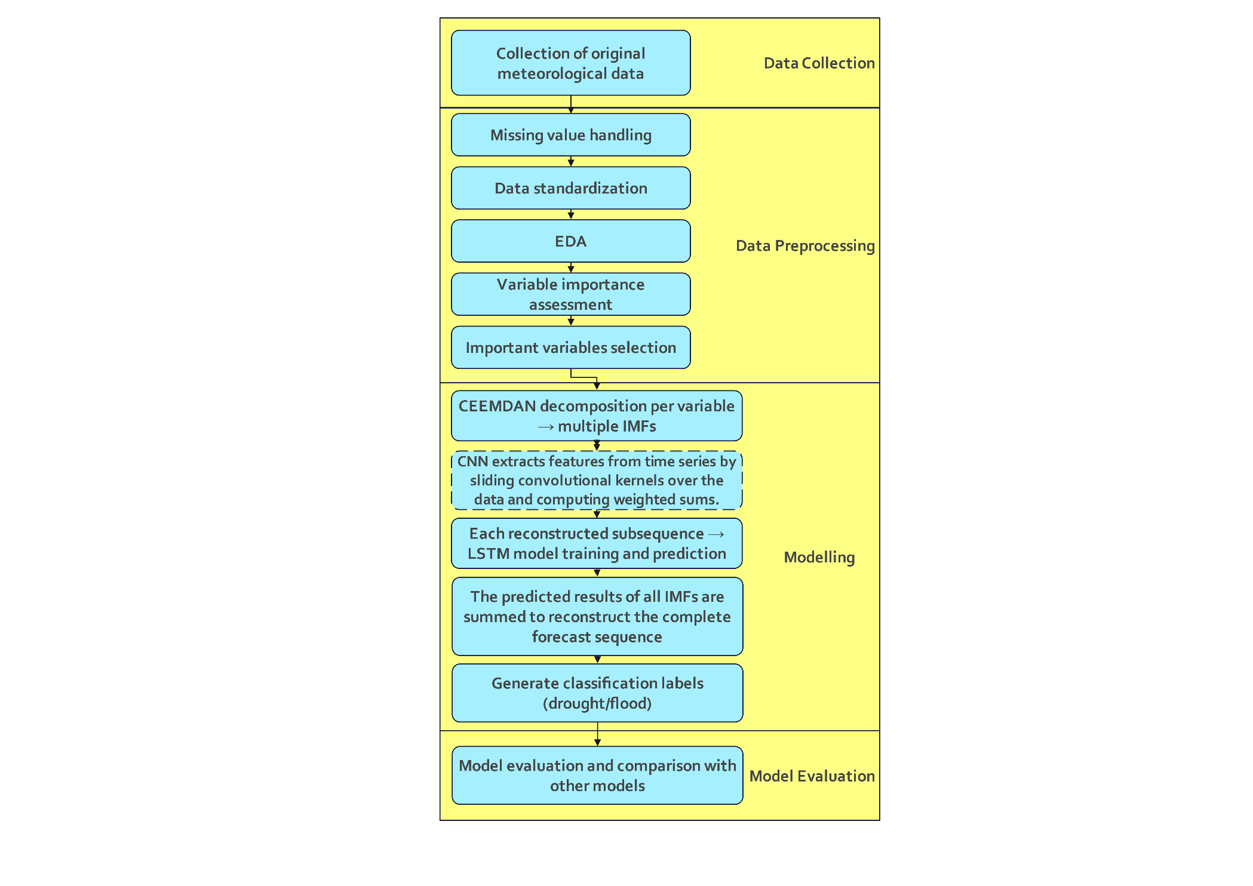
Figure 1 Research Workflow
Data Collection
Data were gathered from publicly available climate archives and portals, Climate Change Knowledge Portal (World Bank). From this source I extracted monthly values for all relevant variables between 1950 and 2023 for the eight target countries (Malaysia, China, India, Indonesia, Japan, Thailand, Philippines, Vietnam).
Data preprocessing
In order to enhance the adaptability and predictive accuracy of the model for extreme weather events, this study systematically preprocessed multivariate meteorological data spanning from 1950 to 2023 prior to model development.
The preprocessing workflow consisted of five key steps: missing value handling, data standardization, exploratory data analysis (EDA), variable importance evaluation, and selection of key variables.
Missing Value Handling
Given that the dataset encompasses meteorological records from multiple countries over a long time period, certain variables and time points may exhibit missing values. To address this issue while preserving temporal and seasonal characteristics, different imputation strategies were applied. For short-term data missing (less than three consecutive months), linear interpolation was employed. For longer continuous segments of missing data, values were imputed using the multi-year historical average for the corresponding month and country, thereby minimizing potential data distortion.
Data Standardization
Due to the inclusion of 15 distinct meteorological variables with varying units and scales, standardization was essential to ensure comparability and prevent bias toward variables with larger magnitudes during model training. This study applied minimum-maximum normalization (Min-Max Scaling) at the country level, transforming all variables into the range [0,1]. This approach ensures uniformity across variables and enhances the reliability of subsequent analytical and modeling processes.
Exploratory Data Analysis (EDA)
Following standardization, each variable undergoes a series of analyses including distribution testing, trend analysis, and extreme value identification. Time series trend plots and box plots are employed to examine the temporal variation characteristics of the variables. This process enables the preliminary identification of periodic patterns, anomalies, and seasonal fluctuations within the data, thereby establishing a foundation for subsequent feature selection and model development.
Variable Importance Assessment
To construct a model with high predictive performance, this study assesses the importance of all 15 meteorological variables by calculating their correlation coefficients with the target variables—consecutive dry days (CDD) for drought prediction and maximum consecutive 5-day precipitation (Rx5Day) for flood prediction. This method enables a quantitative evaluation of the strength of linear relationships between predictors and targets, while also revealing the relative contribution of each variable across different regional contexts. The use of country-level datasets facilitates the identification of region-specific drivers of extreme weather events.
Selection of Important Variables
Based on the results from the correlation analysis, key meteorological variables that achieve the highest correlation with the target variable are selected. Specifically, for each country, the top-ranked variables are combined with the target variable (cdd or rx5day) to form the final modeling dataset. For instance, cdd is often highly correlated with precipitation-related indicators (such as r20mm, pr), while rx5day may show stronger associations with variables like tas or hurs. The selected variables serve as the input feature set for CEEMDAN decomposition and subsequent LSTM-based modeling.
Modelling
In order to achieve accurate prediction of various extreme weather events such as drought, flood and heat wave, this study proposed a combined modeling method based on "decomposition-reconstruction-prediction-integration" and constructed the CEEMDAN-CNN-LSTM model architecture. This method combines the ability of CEEMDAN to extract multi-scale features of climate data, the efficiency advantage of CNN for signal reconstruction, and the powerful performance of LSTM neural network in modeling nonlinear time series.
In addition, the meteorological data used in this study spans from January 1950 to December 2023, comprising a monthly time series. To ensure temporal consistency in model training and validation, the dataset is partitioned chronologically as follows:
Training and validation set: January 1950 – Janauary 2013 (85%), used for model learning and parameter tuning;
Test set: January 2013 – December 2023 (15%), used to evaluate the model's predictive performance;
The whole modeling process includes five main steps:
CEEMDAN decomposes the target variable
First, for each selected target meteorological variable (such as cdd, rx5day, etc.), the CEEMDAN (Complete Ensemble Empirical Mode Decomposition with Adaptive Noise) method is applied. This technique effectively addresses the common "mode mixing" issue present in traditional EMD decomposition by introducing adaptive white noise at each iteration, resulting in multiple IMF components (Intrinsic Mode Functions) that represent different fluctuation frequencies.
These IMF components can be interpreted as subcomponents of the original target variable across various time scales, including quarterly, annual, and multi-year scales. For instance, certain IMFs exhibit seasonal variations (fluctuating every 3–4 months), while others capture interannual or decadal trends. Through this approach, CEEMDAN enables the decomposition of complex and non-stationary climate signals into more regular and analyzable subsequences, thereby facilitating subsequent modeling tasks.
Modeling IMF subsequences with CEEMDAN-CNN-LSTM (or CEEMDAN-LSTM)
Each IMF component of the target variable is directly modeled as an independent prediction task. The supervised samples are constructed by combining a rolling window of the original meteorological predictors (all explanatory features except the target variable) as inputs, with the corresponding next-step value of the IMF as the output. This design preserves both high-frequency and low-frequency patterns without any manual grouping, ensuring that each IMF is learned separately.
Model training and prediction of each IMF subsequence
For each IMF subsequence, a deep learning model is trained:
In the CEEMDAN-CNN-LSTM framework, one-dimensional convolution is applied to extract local temporal patterns, followed by an LSTM layer to capture long-term dependencies.
In the CEEMDAN-LSTM framework, the IMF subsequence is directly fed into an LSTM network, focusing on sequential dependency learning without convolution.
This approach allows the models to capture both short-term fluctuations and long-term tendencies contained in the IMF series.
Summarizing forecast values and reconstructing the complete sequence
After all IMF subsequences have been predicted, their forecasted values are summed along the time axis to reconstruct the complete forecast sequence of the target variable. For example, the model generates predictions for multiple subsequences corresponding to quarterly fluctuations, annual variations, and multi-year trends. These components are then aggregated to form the final forecast sequence for the upcoming months.
This approach enables the simultaneous capture of abrupt extreme events and long-term background tendencies, thereby enhancing both the stability and accuracy of the forecasting process.
Model Evaluation
In order to rigorously evaluate the effectiveness of the proposed models for extreme weather prediction, this study employs a two-stage evaluation strategy covering both regression and classification tasks.
First, in the regression stage, the predictive accuracy of the continuous target variable is assessed using classical numerical metrics, including Mean Squared Error (MSE), Root Mean Squared Error (RMSE), Mean Absolute Error (MAE), Mean Absolute Percentage Error (MAPE), and the coefficient of determination (R²). These indicators provide a comprehensive view of the models’ fitting ability and error magnitude.
MSE (mean squared error): reflects the average of the squared differences between the predicted values ​​and the true values. A smaller value indicates a lower overall error.
RMSE (root mean squared error): is the square root of the MSE and more intuitively indicates the magnitude of the predicted deviation.
MAE (mean absolute error): measures the average of the absolute differences between the predicted values ​​and the true values, reflecting the overall average deviation.
MAPE (mean absolute percentage error): represents the percentage of the predicted values ​​that are incorrect.
R² (coefficient of determination): measures the improvement of a model over a baseline model that directly uses the true mean as its prediction. R²=1 indicates a perfect fit, R²=0 indicates comparable performance to the mean prediction, and R²<0 indicates that the model performs even worse than the mean prediction.
Second, in the classification stage, the predicted continuous values of the target variable are discretized into three drought categories (Non-drought, Slight drought, and Drought) according to predefined thresholds. The classification effectiveness is then evaluated using Accuracy, Macro-averaged Precision, Macro-averaged Recall, Macro-averaged F1 Score, and the confusion matrix.
Accuracy: This represents the proportion of samples correctly predicted by the model out of the total number of samples, used to measure the model's overall predictive ability.
Precision: This represents the proportion of samples predicted as belonging to a certain class (e.g., "drought") that actually belong to that class, reflecting the reliability of the model's predictions.
Recall: This represents the proportion of real-world samples of a certain class that were correctly identified, measuring the model's ability to detect events of that class.
F1 Score: The harmonic mean of precision and recall, particularly useful in cases of imbalanced class distributions, and provides a comprehensive reflection of the model's performance on the minority class.
Confusion Matrix: This matrix displays the correspondence between the true and predicted classes, providing a visual representation of the model's classification accuracy and the main sources of error.
Through this combination of regression and classification evaluations, the study systematically examines how CEEMDAN decomposition and CNN integration enhance predictive performance, and whether the proposed approach yields improved accuracy and stability compared with baseline models. Results are presented in the form of performance tables, confusion matrices, and time-series prediction plots to ensure interpretability and clarity.
EXPERIMENT AND RESULTS
Data collection
Collect the data from Climate Change Knowledge Portal (World Bank). The selected variables align with the study’s extreme-event focus: total precipitation (pr), consecutive dry days (cdd), temperature extremes (tasmax, tasmin), relative humidity (hurs), monthly rainfall aggregates (pr), maximum 1-day and 5-day rain (rx1day, rx5day), and counts of heavy rain days (r20mm, r50mm), days above high-temperature thresholds (hd35, hd40), heat indices (hi35, hi37, hi39), and daily temperature metrics (tasmax, tasmin). Download climate data in separate CSV format for each variable, with each file corresponding to monthly records of one variable for 8 specific countries. Merge these datasets using country and timestamp (year-month) as key identifiers, resulting in a single time series dataset containing all variables, 8 countries × 74 years × 12 months × 15 variables.
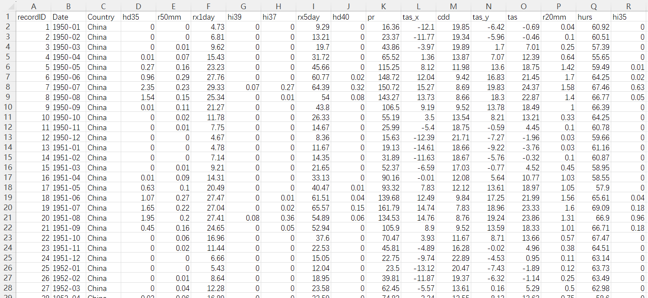
Figure 2 climate_15vars dataset
Data preprocessing
Missing Valve Handling
As an initial step in the data preprocessing phase, this study conducted a systematic assessment for the presence of missing values. A missing value matrix was generated using the missingno library and complemented with an analysis of the data structure obtained from the df.info() function. The findings revealed that the meteorological dataset utilized in this research consisted of 7,104 observations and 18 variables (including date, country, and 15 meteorological parameters). Each variable exhibited a Non-Null Count of 7,104, confirming the absence of missing values throughout the dataset. Additionally, the missing value matrix visualization displayed fully solid bars across all columns, further affirming the completeness of the data. Consequently, no missing value imputation was required, and the dataset was deemed suitable for subsequent feature engineering and model development.
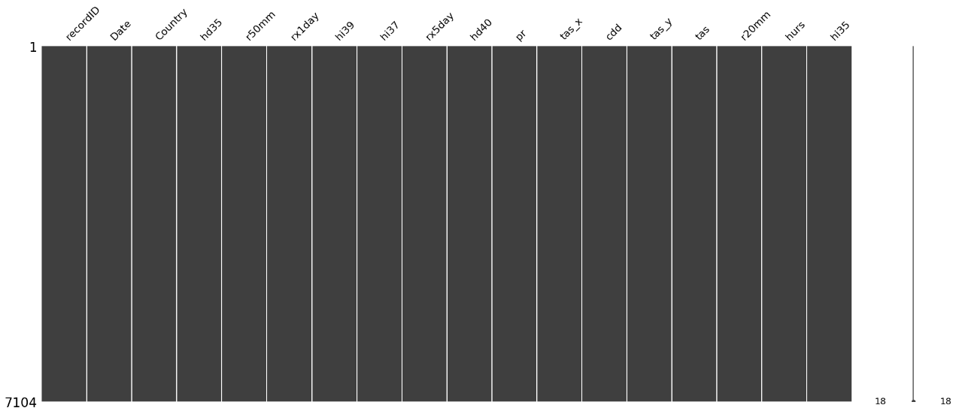
Figure 3 missing value matrix
Data Standardization
In the construction of supervised learning samples, the input comprises multiple meteorological variables, excluding the target variable. Subsequently, the MinMaxScaler is applied to normalize each input feature to the interval [0, 1]. This normalization ensures that different meteorological indicators—such as precipitation, temperature, and humidity—are brought to a comparable numerical scale during model training, thereby preventing features with larger magnitudes from disproportionately influencing the parameter updates of the model.
Furthermore, during the forecasting phase, the model output undergoes standardization. Consequently, to enable meaningful comparison with actual observations, the forecasted values must be inverse-transformed to their original scale. This process ensures that the final output retains both the original dimensionality and physical interpretation of the meteorological variables.
Exploratory Data Analysis (EDA)
Prior to constructing the predictive model, this study conducted a comprehensive explororatory data analysis (EDA) on the dataset. The primary objective of EDA was to gain a thorough understanding of the data characteristics prior to modeling, including the identification of potential outliers, missing values, and underlying distribution patterns. Additionally, EDA facilitated the examination of temporal and spatial trends of meteorological variables. To achieve these objectives, this study employed visualization tools such as Tableau to present extreme climate indices from multiple perspectives, including time series trends, spatial distribution patterns, and inter-variable correlation analysis. This analytical phase not only contributed to validating the data's reliability but also provided a critical reference for subsequent modeling decisions.
Figure 4 presents a geographic map visualization. Users are able to select a single meteorological variable from the dataset and dynamically observe its temporal trends across countries using the interactive time slider. Taking Consecutive Dry Days (CDD) as an example, the visualization enables a direct comparison of drought severity among Asian countries in February 2023: relatively high CDD values are observed in China, India, and Thailand, whereas significantly lower values are recorded in Indonesia and Japan. Such map visualizations effectively illustrate the spatial heterogeneity and temporal dynamics of extreme climate events, thereby offering valuable insights for subsequent model analysis.
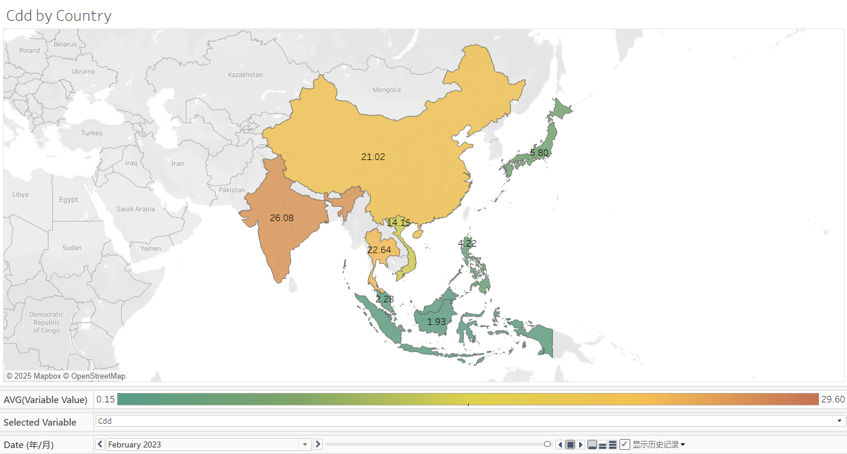
Figure 4 map
The bar chart presented in Figure 5 illustrates the average levels of extreme climate indicators across different countries during the study period. The left panel, using Consecutive Dry Days (CDD) as an example, depicts the overall drought severity across nations. India and China exhibit relatively higher drought intensity, whereas several Southeast Asian countries—such as the Philippines, Indonesia, and Malaysia—experience comparatively lower levels. The right panel displays national averages for Rx5Day (Maximum 5-day Precipitation). Indonesia and the Philippines show higher levels of extreme precipitation, while China and India exhibit lower levels. This comparative analysis clearly highlights the distinct climatic characteristics of drought and heavy precipitation across various countries.
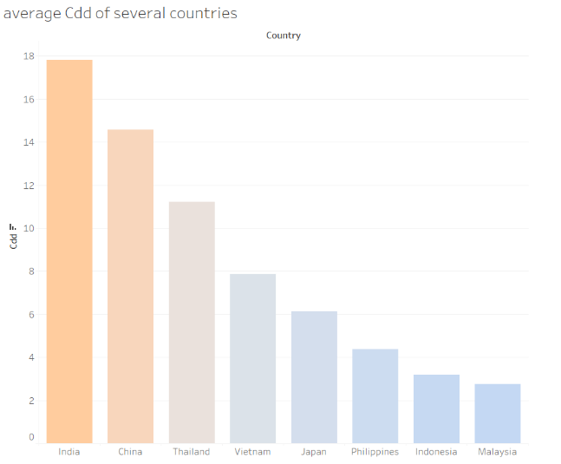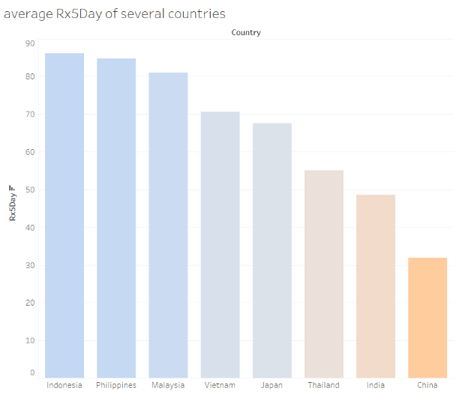
Figure 5 bar charts
The figure presents the results of a statistical analysis conducted on all observations based on predefined classification criteria. The left panel illustrates the classification of Consecutive Dry Days (CDD), with thresholds defined as follows: less than 11 days for "non-drought," 11–15 days for "slight drought," and 16 days or more for "drought." The analysis reveals that the majority of records fall into the "non-drought" category, comprising over 70% of the total sample, whereas "drought" and "slight drought" categories represent a smaller proportion of the data. The right panel displays the classification of Maximum 5-day Precipitation (Rx5Day), with thresholds set at less than 50 mm for "non-flood," 50–99 mm for "slight flood," and 100 mm or more for "flood." The results indicate that "slight flood" events constitute the most frequent category, followed by "non-flood" and "flood" events. This categorical statistical analysis provides an intuitive representation of the distribution of extreme climate events within the historical dataset, offering essential data support for subsequent model training and evaluation (as shown in Figure 6).
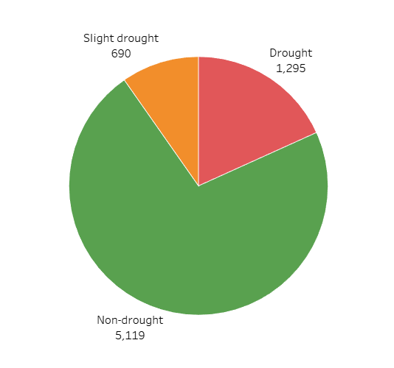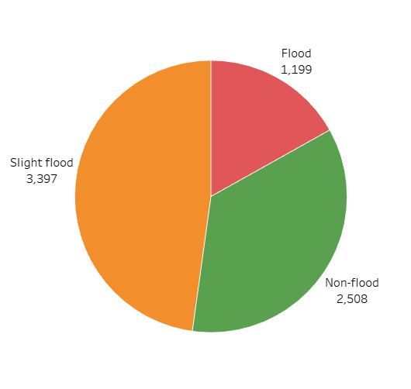
Figure 6 pie charts
Figure 7 illustrates the monthly variations of two climate indicators—Rx5Day (maximum consecutive 5-day precipitation) and CDD (consecutive dry days)—in China and Malaysia from 1950 to 2023. The line chart highlights the seasonal and cyclical differences in extreme climate events between the two countries:
(1) Regarding the CDD indicator, China exhibits a clear seasonal pattern, with a higher number of dry days occurring during winter and spring, and a significant decrease in dry days during summer due to concentrated rainfall. In contrast, Malaysia has consistently maintained low and stable CDD values with minimal fluctuations, suggesting a much lower frequency and persistence of drought events compared to China.
(2) With respect to the Rx5Day indicator, China experiences pronounced seasonal variability, characterized by concentrated and intense precipitation events during summer, which reflects the strong influence of the East Asian monsoon climate on extreme rainfall. Malaysia, on the other hand, shows relatively small annual fluctuations in precipitation, yet frequent and consistently intense extreme rainfall events, which are indicative of the typical characteristics of a tropical monsoon climate.
The comparison of long-term trends between the two countries further confirms the variability of extreme meteorological indicators across different climate zones, thereby providing a scientific basis for evaluating the generalization capability of subsequent models in cross-regional forecasting.
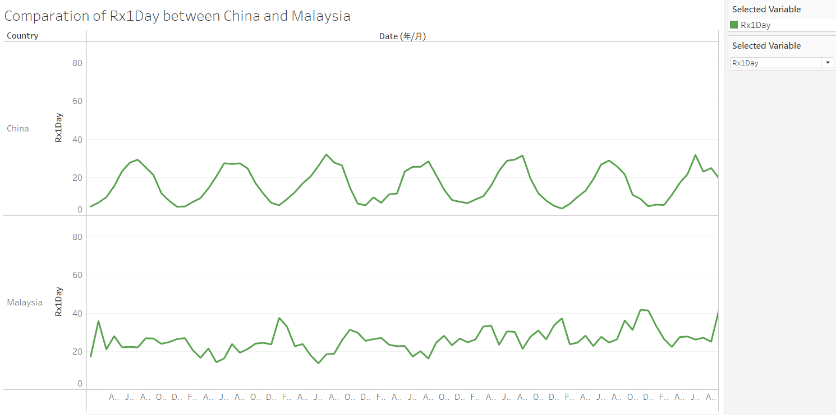
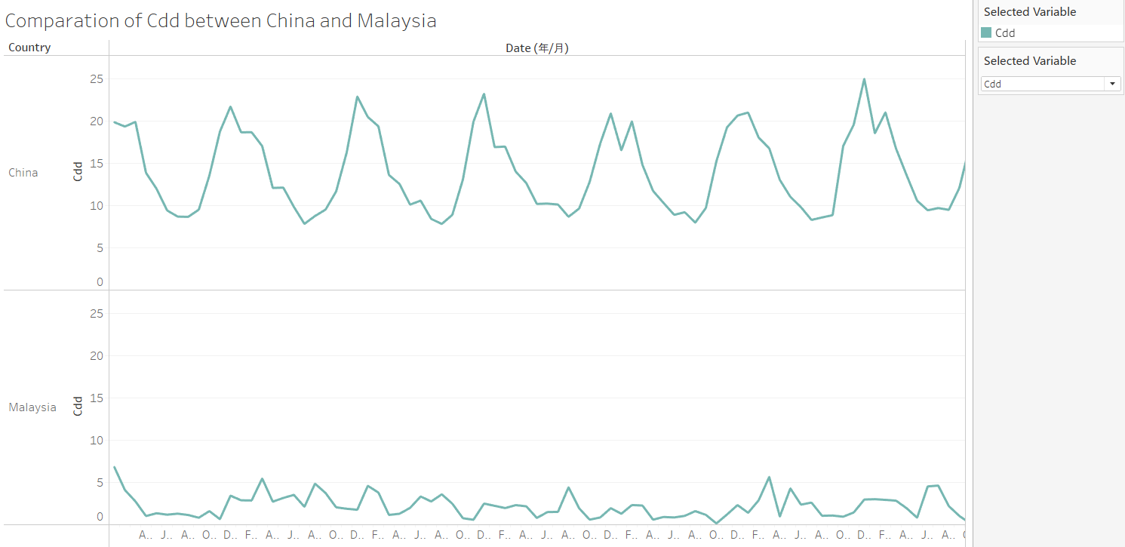
Figure 7 line charts
Variable Importance Assessment
Prior to model construction, it is essential to evaluate the importance of the original meteorological variables in order to identify those that contribute most significantly to the prediction of extreme climate events. In this study, the global meteorological dataset was partitioned by country, resulting in eight independent sub-datasets (China, India, Indonesia, Japan, Malaysia, Philippines, Thailand, and Vietnam), which support national-scale predictive modeling.
For each country-specific dataset, the number of consecutive dry days (CDD) was selected as the target variable for drought prediction, while the monthly maximum 5-day precipitation (Rx5Day) was chosen as the target for extreme rainfall forecasting. Subsequently, the correlation coefficients (CCs) between each of the 15 meteorological variables and the respective target variable were calculated. The correlation coefficient quantitatively measures the strength of the linear relationship between a variable and the target. Values approaching ±1 indicate a strong correlation, whereas values near 0 suggest a weak or negligible relationship.
The results across the country-specific datasets demonstrate notable regional variations in variable importance. For instance, in the Chinese dataset, the correlation coefficients between CDD and R20mm reached 0.919 and 0.888, respectively, indicating that precipitation frequency has substantial explanatory power for drought prediction. In contrast, in the Indian dataset, TASMAX exhibited an even higher correlation with CDD, suggesting that temperature-related variables play a more prominent role in drought occurrence in that region.
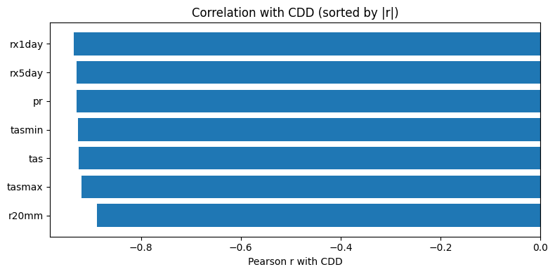
Figure 8 Top seven variables most associated with CDD (China)
This correlation coefficient-based assessment of variable importance not only provides a quantitative foundation for subsequent model training but also highlights regional differences in climatic drivers, thereby enhancing the regional adaptability and generalization capability of the predictive models.
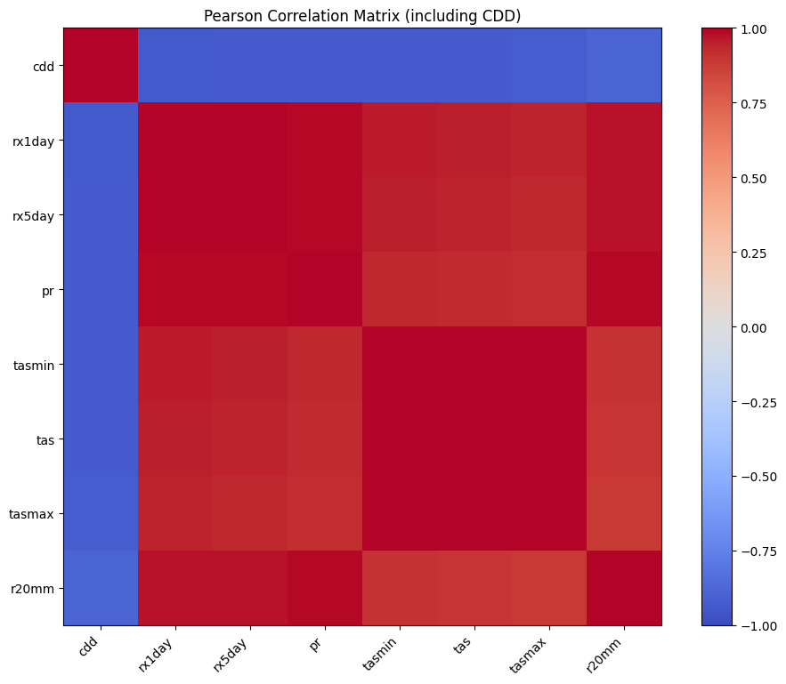
Figure 9 heatmap - CDD (China)
Selection of Important Variables
Following the evaluation of variable importance, this study further ranked the meteorological variables based on their correlation coefficients to identify the top seven factors with the strongest relationships to the target variable (CDD or Rx5Day). These selected variables, together with the target variable, constituted the final modeling dataset for each country.
The selection process was conducted as follows:
- For the drought prediction task, CDD was used as the target variable, and the seven meteorological variables exhibiting the highest correlation coefficients were chosen as input features.
- For the extreme precipitation prediction task, Rx5Day was selected as the target variable, and similarly, the seven variables with the highest correlations were included as predictors.
This feature selection approach effectively reduces model dimensionality while preserving the most informative meteorological variables, thereby minimizing the impact of noise from redundant or less relevant features. For example, in the Chinese drought prediction dataset, CDD was retained as the target variable due to its strong correlations with R20mm, PR, and TASmin. In contrast, in the Indonesian flood prediction dataset, Rx5Day showed higher correlations with TAS and HURS, and these variables were therefore included in the model training dataset.
Ultimately, drought prediction datasets and flood prediction datasets were constructed for all eight countries, providing the necessary data foundation for subsequent model experiments involving CEEMDAN-CNN-LSTM, CEEMDAN-LSTM, and LSTM architectures.
CEEMDAN Decomposition
CEEMDAN decomposition principle
Complete Ensemble Empirical Mode Decomposition with Adaptive Noise (CEEMDAN) is an advanced improvement of both Empirical Mode Decomposition (EMD) and Ensemble Empirical Mode Decomposition (EEMD). By introducing adaptive noise at each decomposition stage, CEEMDAN effectively mitigates mode aliasing and enhances the completeness and stability of the decomposition process. This method is particularly well-suited for analyzing nonlinear and nonstationary meteorological time series data.
In the context of climate extreme event prediction, this study applies the CEEMDAN method to decompose two key climate indicators: the drought metric, consecutive dry days (CDD), and the extreme precipitation metric, maximum five-day precipitation (RX5day). This decomposition enables the extraction of characteristic components across multiple time scales. The detailed procedure of the CEEMDAN decomposition is outlined as follows:
(1) Add Gaussian white noise$ε_{i}ω^{i}\left(t\right)$ to the original signal $y\left(t\right)$, constructing multiple noisy signals:
$$y_{i}\left(t\right)=y\left(t\right)+ε_{0}ω^{i}\left(t\right), i=1,2,…,N$$
Where $y_{i}\left(t\right)$ denotes the signal after the i-th addition of noise; $ε_{0}$ is the noise coefficient; and $ω^{i}\left(t\right)$ represents the i-th Gaussian white noise.
(2) Perform Empirical Mode Decomposition (EMD) on each noisy signal $y_{i}\left(t\right)$ to obtain the first Intrinsic Mode Function (IMF) component $c_{1}^{i}\left(t\right)$, and calculate their mean as the first IMF component $c_{1}\left(t\right)$:
$$c_{1}\left(t\right)=\frac{1}{N}\sum_{i=1}^{N}{c_{1}^{i}\left(t\right)}$$
At the same time, compute the residual:
$$r_{1}\left(t\right)=y\left(t\right)-c_{1}\left(t\right)$$
where $r_{1}\left(t\right)$ represents the residual of the first decomposition.
(3) Iterate on the residual. Add new noise to the residual $r_{j}\left(t\right)$ and perform EMD again to obtain the next IMF component $r_{j+1}\left(t\right)$:
$$c_{j+1}\left(t\right)=\frac{1}{N}\sum_{i=1}^{N}{E_{1}\left(r_{j}\left(t\right)+ε_{j}E_{j}\left(ω^{i}\left(t\right)\right)\right)}$$
Then update the residual:
$$r_{j+1}\left(t\right)=r_{j}\left(t\right)-c_{j+1}\left(t\right)$$
Where $E_{j}\left(⋅\right)$ denotes the j-th mode operator of EMD decomposition, and $ε_{j}​$ is the noise coefficient at step j.
(4) Repeat step (3) until the residual satisfies the monotonic condition or the decomposition reaches the predefined number of iterations. At this stage, all IMF components and the final residual are obtained.
5) Signal reconstruction. The original signal $y(t)$can be represented as the sum of all IMF components and the final residual $r_{M}\left(t\right)$:
$$y\left(t\right)=\sum_{m=1}^{M}{c_{m}\left(t\right)}+r_{M}\left(t\right)$$
where $M$ is the total number of IMF components; $c_{m}\left(t\right)$ denotes the m-th IMF component; and $r_{M}\left(t\right)$ represents the final residual.
Climate target variable decomposition implementation
This study applies the CEEMDAN algorithm from the PyEMD library to decompose climate extreme indices in China over the period from January 1961 to December 2022. For the purpose of drought prediction, the CDD (Consecutive Dry Days) index is decomposed using CEEMDAN; for extreme precipitation prediction, the RX5day (Maximum 5-day Precipitation) index is utilized. The detailed implementation procedure is as follows:
- The monthly climate time series data are converted into pandas Series format, using time as the index: $S=\{s_{t}​∣t∈T\}$，where $S$ represents the time series, $s_{t}$ is the observed value at time $t$, and $T$ denotes the set of time indices.
- Parameter setting: The key parameter for CEEMDAN decomposition is configured, including the number of noise-assisted trials ($trials=100$), to ensure the stability and reliability of the decomposition.
- Decomposition execution: The CEEMDAN algorithm is applied to the time series for decomposition: $IMFs=CEEMDAN(S,trials)$
- The decomposition results in an IMF (Intrinsic Mode Function) matrix of size $K×L$, where $K$is the number of IMFs and $L$ is the length of the time series.
- Feature analysis of components: For the CDD index, CEEMDAN produces 8 IMF components ($imf1-imf8$); for the RX5day index, CEEMDAN produces 9 IMF components ($imf1-imf9$). Each IMF represents oscillatory modes of the original signal at different temporal scales:
High-frequency components $(imf1-imf3)$: Reflect short-term climate fluctuations, with periods typically ranging from several months to one year.
Mid-frequency components $(imf4-imf6)$: Capture interannual variability, with periods of approximately 2–5 years.
Low-frequency components $(imf7 and above)$: Represent long-term climate trends and large-scale variation characteristics.
As figure 10 and figure 11, through CEEMDAN decomposition, the original complex climate signal is decomposed into multiple intrinsic mode functions (IMFs) and a single residual trend term, with each IMF representing oscillations at distinct temporal scales. This multi-scale decomposition offers more refined insights into climate variability and extreme events, thereby improving the interpretability and predictive performance of subsequent modeling tasks.
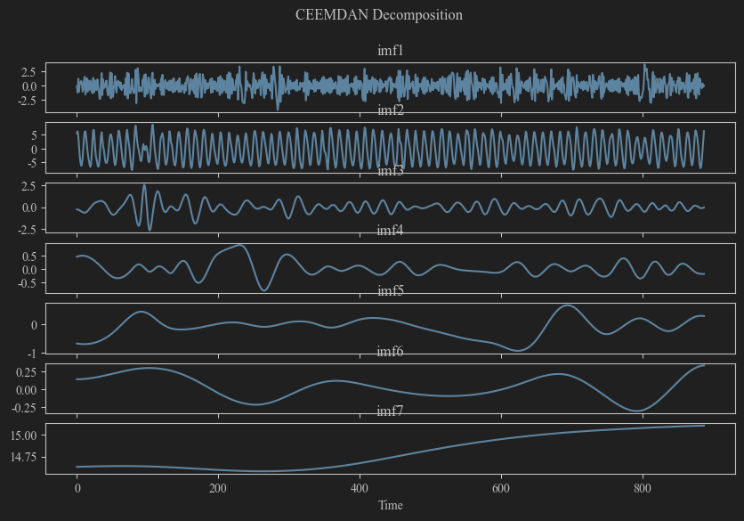
Figure 10 CEEMDAN Decomposition for Cdd of China
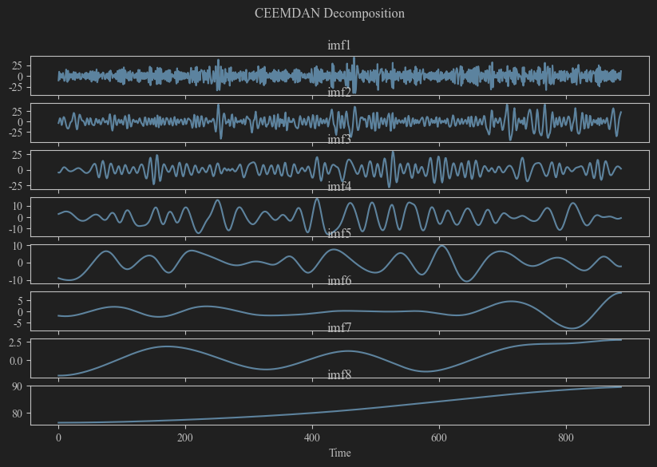
Figure 11 CEEMDAN Decomposition for Rx5day of Malaysia
CNN
The principle and structure of CNN
Convolutional Neural Networks (CNNs) were initially developed for image recognition tasks. In recent years, due to their strong capability in extracting local features, CNNs have been increasingly applied to time series prediction. By using convolutional layers, CNNs automatically capture local characteristics of input data, enabling them to effectively identify short-term patterns and local dependencies within time series. A key advantage of CNNs lies in their ability to significantly reduce the number of model parameters through mechanisms such as parameter sharing and local connectivity, thereby improving computational efficiency without compromising feature extraction performance.
The fundamental architecture of a CNN typically consists of the following components:
(1) One-dimensional convolutional layer (Conv1D): This layer performs convolution operations on time series data to extract local temporal features. The convolution kernel slides along the time dimension, capturing short-term dependencies among meteorological variables.
(2) Pooling layer: This layer reduces the spatial dimensions of features through downsampling, lowering computational complexity while preserving critical feature information. Max pooling, in particular, is effective in highlighting the most salient local features.
(3) Activation function: This introduces non-linear transformation capabilities into the model. In this study, the ReLU activation function is employed, defined as f(x) = max(0, x), which helps mitigate the problem of gradient vanishing during training.
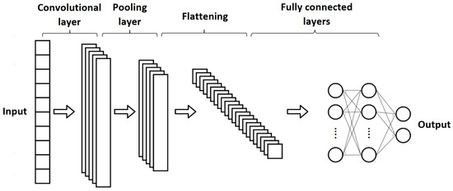
Figure 12 The 1DCNN architecture.
The Application of CNN in Extreme Climate Prediction
In the CEEMDAN-CNN-LSTM framework employed in this study, the CNN module is designed for local feature extraction. The detailed implementation process is outlined as follows:
(1) Input data preprocessing: Multidimensional meteorological variables, including precipitation (pr), maximum temperature (tasmax), minimum temperature (tasmin), and average temperature (tas), are reconstructed into a three-dimensional tensor to meet the input requirements of the CNN. Time step will be set as 5, can not only capture the short-term variation patterns of meteorological elements, but also avoid the gradient disappearance problem caused by too long a window.
(2) Convolutional feature extraction: A one-dimensional convolutional layer is implemented with 32 convolution kernels, each having a kernel size of 2. The mathematical formulation for the convolution operation is as follows:
$$y_{i}=σ\left(\sum_{j=0}^{k-1}{w_{j}}⋅x_{i+j}+b\right)$$
Where $w_{j}$ represents the convolution kernel weight, $x_{i+j}$ represents the input sequence, $b$ represents the bias term, and $σ$ represents the ReLU activation function. This setting effectively extracts the changing patterns of meteorological elements between adjacent time steps.
(3) Pooling Dimensionality Reduction: A max pooling layer (pool_size=2) is used to downsample the convolutional feature map, retaining the maximum response value in each local region. This not only reduces the feature dimension (from half the original time step length) but also enhances the model's sensitivity to local extreme features, which is particularly important for extreme climate event prediction.
(4) Feature Reshaping: The pooled features are reshaped into the [batch_size, time_steps, features] format through the Reshape layer to provide an adaptive input for the subsequent LSTM layer. The reshaped feature dimension is (-1, 32), retaining all feature channels extracted by the 32 convolution kernels.
Model Training and Optimization
The CNN module and LSTM are sequentially connected to construct an end-to-end deep learning architecture. During the training phase:
Optimizer: The Adam optimization algorithm is employed, which enables adaptive learning rate adjustment.
Batch size: A batch size of 32 is selected to balance training efficiency with gradient stability.
Number of training epochs: The model is trained for 100 epochs to ensure it fully captures the underlying data patterns.
By leveraging CNN feature extraction, the model effectively captures short-term fluctuation patterns in meteorological variables, providing refined feature representations for the LSTM. This hierarchical feature learning strategy substantially enhances the accuracy of predictions for extreme climate events.
LSTM Training
The principle of LSTM
Long Short-Term Memory (LSTM) is a specialized type of recurrent neural network that effectively addresses the vanishing and exploding gradient problems commonly encountered in traditional RNNs when processing long sequential data, through the introduction of memory cells and gating mechanisms. LSTM networks are capable of efficiently capturing long-term dependencies in meteorological time series data, making them highly significant for the prediction of extreme climate events. The LSTM neuron structure comprises three gating units and one memory cell: (1) Input Gate: This gate controls the extent to which current input information is allowed to enter the memory cell. It consists of a sigmoid activation function and a tanh activation function, with the corresponding mathematical formulation being:
$$i_{t}=σ!\left(W_{i}⋅\left[h_{t-1},x_{t}\right]+b_{i}\right)$$
$$\tilde{C_{t}}=\tanh{!}\left(W_{C}⋅\left[h_{t-1},x_{t}\right]+b_{C}\right)$$
Where $i_{t}$ is the activation value of the input gate; $σ$ is the sigmoid activation function; $h_{t-1}$ is the hidden layer state at the previous moment; $x_{t}$ is the input at the current moment; $Wi$and $W_{C}$ is the weight matrix; $b_{i}$ and $b_{C}$ is the bias term.
(2) Forget Gate: This gate determines which information within the memory cell should be retained or discarded. The relevance of the information is weighted through a sigmoid activation function. A weight close to 1 signifies that the information is preserved, while a value near 0 indicates that it is to be discarded. The corresponding mathematical formulation is:
$$f_{t}=σ!\left(W_{f}⋅\left[h_{t-1},x_{t}\right]+b_{f}\right)$$
Where $f_{t}$ is the activation value of the forget gate; $W_{f}$​is the weight matrix; and $b_{f}$ ​is the bias term.
(3) Memory Cell: The memory cell serves as the core component of the LSTM architecture, responsible for storing and transmitting long-term information. It maintains temporal continuity within the sequence, enabling the network to retain past information and utilize it in current computations when necessary. The primary mathematical formulation is:
$$C_{t}=f_{t}⋅C_{t-1}+i_{t}⋅\tilde{C_{t}}$$
Where $C_{t}$ is the memory cell state at the current moment; $C_{t-1}$ ​is the memory cell state at the previous moment.
(4) Output Gate: This gate controls the extent to which information stored in the memory cell is passed to the hidden layer. It is determined by both a sigmoid activation function and a tanh activation function. The output of the sigmoid function determines the weight of the information to be output, while the output of the tanh function represents the content of the information stored in the memory cell. The corresponding mathematical formulation is:
$$o_{t}=σ!\left(W_{o}⋅\left[h_{t-1},x_{t}\right]+b_{o}\right)$$
$$h_{t}=o_{t}⋅\tanh\left(C_{t}\right)$$
Where $o_{t}$ is the activation value of the output gate; $W_{o}$is the weight matrix; $b_{o}$​is the bias term; and $h_{t}$​is the hidden layer state at the current moment.
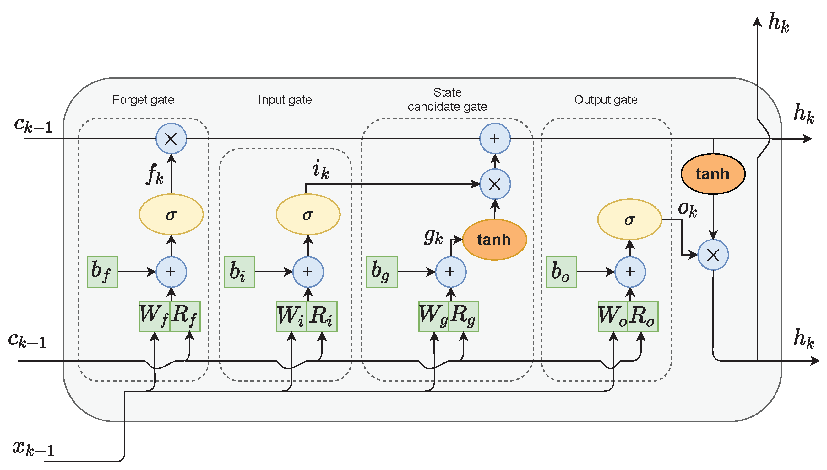
Figure 13 LSTM neuron architecture
Modeling of LSTM in CEEMDAN-CNN-LSTM
In the CEEMDAN-CNN-LSTM framework, the LSTM serves as the final time series prediction module, receiving high-level features extracted by the CNN for temporal modeling. The detailed implementation process is as follows:
(1) Feature reception and conversion: The LSTM layer receives the feature output from the CNN pooling layer. After dimensionality adjustment through the Reshape layer, the feature dimension becomes (-1, 32), where 32 corresponds to the number of convolution kernels in the CNN layer. This design ensures effective feature representation across both temporal and spatial dimensions.
(2) LSTM network configuration: A single-layer LSTM architecture is employed, consisting of 128 hidden units. The activation function used is the Scaled Exponential Linear Unit (SELU), which is mathematically defined as:
$$SELU\left(x\right)= λ · \left\{ x if x > 0 ; α\left( eˣ - 1 \right) if x ≤ 0 \right\}$$
Among them, λ ≈ 1.0507 and α ≈ 1.6733. The SELU activation function possesses the self-normalizing property, which enables stable gradient propagation in deep networks and makes it particularly suitable for capturing nonlinear patterns in meteorological data.
(3) Sequence processing mechanism: Setting return_sequences=False indicates that the LSTM returns only the output from the final time step, compressing the temporal dependencies of the entire sequence into the final hidden state. This configuration is appropriate for single-step prediction tasks, with the output dimension being (batch_size, 128).
(4) Output mapping: The LSTM output is mapped to the target dimension through a fully connected (Dense) layer. For the prediction of extreme climate indicators, the output dimension is set to 1, corresponding to the predicted value of a single IMF component. Ultimately, the prediction results of all IMF components are aggregated and reconstructed to yield the complete prediction of the target variable.
LSTM Process Modeling in CEEMDAN-LSTM
The CEEMDAN-LSTM model excludes the CNN feature extraction step and directly employs LSTM to process the original multivariate meteorological features for predicting each IMF component. The modeling procedure is as follows:
(1) Input data organization: Multidimensional meteorological features (e.g., precipitation, temperature, humidity) are structured into a three-dimensional tensor of shape [batch_size, time_steps, features] based on a sliding time window. The time step is uniformly set to 5, ensuring that short-term variations in meteorological elements are captured while mitigating gradient-related issues caused by excessively long sequences.
(2) LSTM architecture design: A standard LSTM layer is implemented, comprising 128 memory units. The default tanh activation function is used for cell state transformation, while the gate mechanisms are controlled using the sigmoid function. This architecture is relatively simple, with fewer parameters and higher computational efficiency:
Input dimension: (5, n_features), where n_features denotes the number of meteorological features
LSTM layer: 128 units, return_sequences=False
Output layer: Dense(1), linear activation
(3) Time series feature learning: The LSTM adaptively learns temporal dependencies among meteorological variables through its gating mechanisms. The input gate selectively incorporates current meteorological information, the forget gate filters out irrelevant historical information, and the output gate regulates the feature representation passed to the subsequent layer. This mechanism enables the model to effectively capture precursor signals of extreme climate events.
(4) Multi-component collaborative prediction: For each IMF component obtained via CEEMDAN decomposition, an individual LSTM model is constructed for prediction. These models are trained in parallel, with each undergoing independent parameter optimization. Finally, the predicted values of all IMF components are combined to reconstruct the complete prediction of the extreme climate indicator. This divide-and-conquer strategy reduces the complexity of individual models and enhances the overall prediction accuracy.
Classification
After completing the regression predictions, this section converts the continuous predicted values into discrete risk categories to evaluate the model's performance in classifying extreme climate events.
For the classification experiment on consecutive drought days (CDD), the predicted and true values in the test set were first flattened to ensure consistency in data dimensionality. Based on predefined threshold rules, the continuous CDD values were categorized into three drought levels: CDD less than 11 days was labeled as "non-drought" (category 0), CDD between 11 and 15 days was labeled as "mild drought" (category 1), and CDD of 16 days or more was labeled as "drought" (category 2). Following this classification transformation, the scikit-learn library was employed to compute a range of classification evaluation metrics, including accuracy, error rate, macro-averaged F1 score, macro-averaged precision, and macro-averaged recall. A 3×3 confusion matrix was also generated, with rows representing the true categories and columns representing the predicted categories. To support further analysis, monthly classification results were exported as CSV files, which included the month timestamp, true CDD value, predicted CDD value, true class label, predicted class label, and corresponding textual description for each class.
A similar procedure was applied in the classification experiment for maximum 5-day precipitation (rx5day). The predicted and true values were first flattened, then classified based on flood risk thresholds: rx5day less than 50 mm was labeled as "non-flood" (class 0), rx5day between 50 and 100 mm was labeled as "minor flood" (class 1), and rx5day greater than or equal to 100 mm was labeled as "flood" (class 2). Classification performance metrics were computed using the same evaluation framework, including accuracy, error rate, macro-averaged F1 score, macro-averaged precision, and macro-averaged recall. A confusion matrix was generated to illustrate the classification performance across classes. Additionally, a detailed classification report was produced using the classification_report function, showing precision, recall, F1 score, and the number of support examples for each category. The experimental results were also exported as CSV files containing complete monthly classification information: month timestamp, true rx5day value, predicted rx5day value, true category label, predicted category label, and corresponding textual description.
PRACTICAL RESULTS AND INSIGHTS
Regression and classification result
Through prediction experiments on multiple extreme climate events, we systematically evaluated and compared the performance of the CEEMDAN-CNN-LSTM hybrid model against several baseline models. For regression tasks, the experimental results were assessed using multiple evaluation metrics, including mean squared error (MSE), root mean squared error (RMSE), mean absolute error (MAE), mean absolute percentage error (MAPE), and the coefficient of determination (R²). Comparative analysis was further supported by examining prediction curves. For classification tasks, we considered metrics such as accuracy, error rate, macro-averaged F1 score, macro-averaged precision, and macro-averaged recall.
The experimental results indicate that the hybrid model proposed in this study generally exhibits superior predictive performance in most cases.
As shown in Figure 5.4, when analyzing drought conditions, the integration of CEEMDAN decomposition with deep learning models demonstrates better predictive accuracy compared to the standalone LSTM model in most countries. Specifically, the CEEMDAN-LSTM and CEEMDAN-CNN-LSTM models achieve significantly improved prediction accuracy in China, India, Indonesia, the Philippines, Thailand, and Vietnam. However, when applied to eight different countries, the model's predictive performance varied considerably.
For instance, China and India showed a strong correlation between meteorological variables and CDD (Cumulative Drought Duration), leading to higher model prediction accuracy compared to other countries. The CEEMDAN-based models achieved slight reductions in both RMSE and MAE compared to the LSTM model, suggesting that decomposition techniques and hybrid modeling approaches can further enhance predictive performance in scenarios with strong data correlations. For example, in the drought prediction task for China, the MAPE values of the three models were as follows:
LSTM model: 7.78% (Figure 14)
CEEMDAN-CNN-LSTM model: 7.47% (Figure 15)
CEEMDAN-LSTM model: 7.20% (Figure 16)
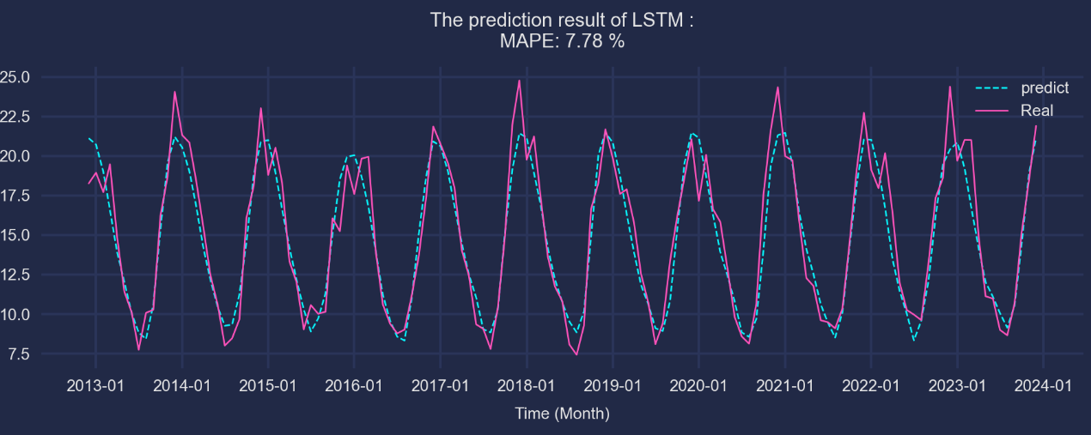
Figure 14 LSTM result (China Drought)
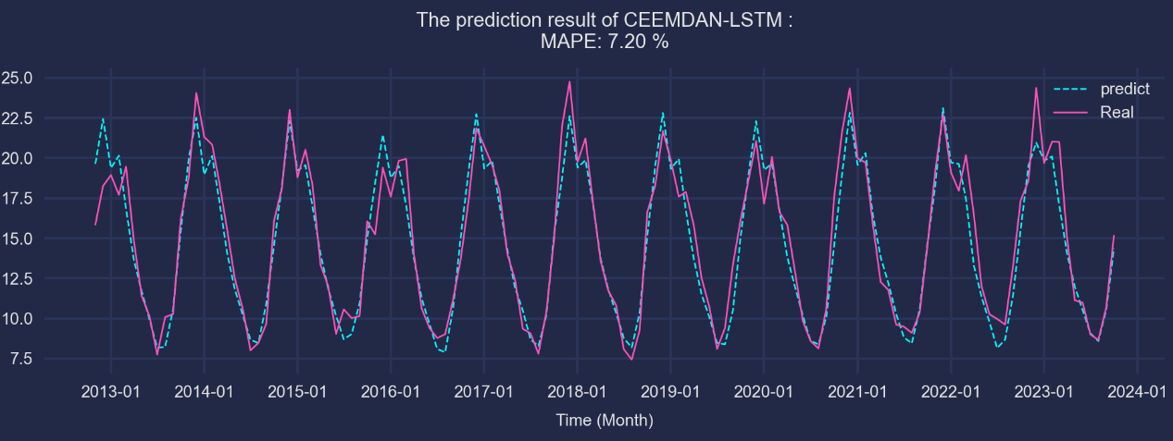
Figure 15 CEEMDAN-LSTM result (China Drought)
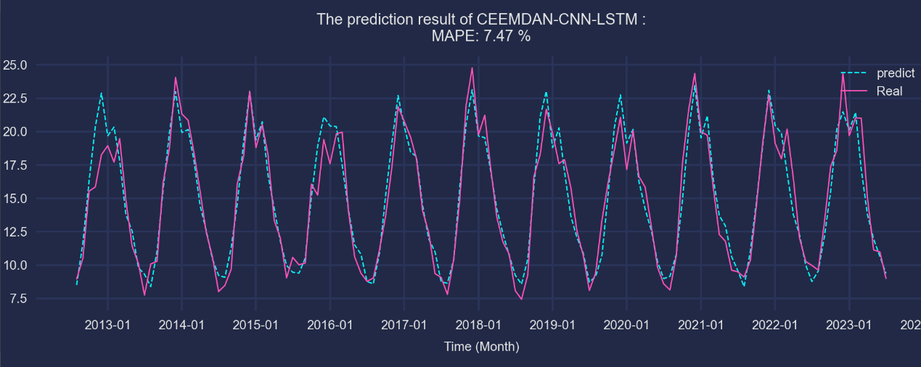
Figure 16 CEEMDAN-CNN-LSTM result (China Drought)
Results for Indonesia and the Philippines generally outperformed those for Japan and Malaysia; however, MAPE remained relatively high (approximately 37%–44%), indicating the greater nonlinearity and instability of precipitation and drought variations in tropical humid regions, which makes it more challenging for the model to capture extreme fluctuations. Nevertheless, the CEEMDAN-based models still provided some improvement in forecasting performance, reducing MAPE by approximately 3–5%.
In Thailand and Vietnam, the forecast results were relatively satisfactory. Both the CEEMDAN-LSTM and CEEMDAN-CNN-LSTM models outperformed the standard LSTM model across metrics such as RMSE, MAE, and R². Specifically, in Thailand, the CEEMDAN-CNN-LSTM model achieved an R² of 84.26%, approximately 3% higher than that of the LSTM model, highlighting the model's robustness under the continental climate conditions of Southeast Asia.
However, in the prediction of CDDs for Japan and Malaysia, the CEEMDAN-based models failed to improve forecasting performance and, in some cases, led to a decline. For example, the R² of the LSTM model in Japan was -9.32%, while that of the CEEMDAN-CNN-LSTM model dropped further to -72.81%. Malaysia also experienced a decrease in R² and a significant increase in MAPE. This is primarily attributed to the weak correlation between meteorological variables and CDD (with the highest correlation coefficient ranging only between 0.44 and 0.75), which resulted in the decomposed IMF components failing to provide meaningful predictive information and instead introducing noise into the modeling process.
Table 2 Summary of Drought Prediction Results
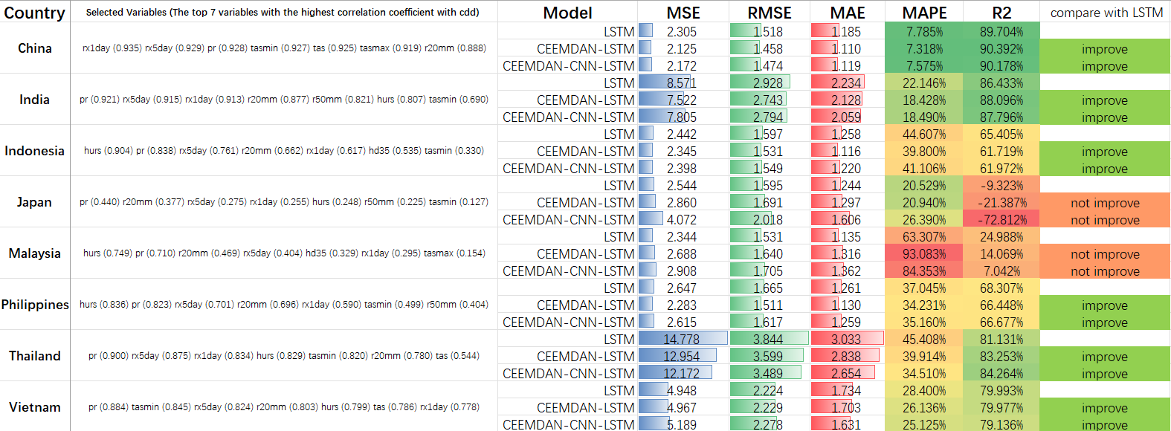
This regional variation reflects the differences in the formation mechanisms and spatiotemporal characteristics of drought events across regions. The model demonstrated better performance in monsoon-dominated areas, such as China and India, likely due to the more cyclical and predictable nature of droughts in these regions.
For the drought severity classification task, this study categorized the CDD index into three classes: non-drought (<11), mild drought (11–15), and drought (≥16). The classification performance of three models—LSTM, CEEMDAN-LSTM, and CEEMDAN-CNN-LSTM—was evaluated using data from China as a case study.
The results indicate that all three models achieved high overall classification accuracy, with the CEEMDAN-CNN-LSTM model performing the best at 90.15%, surpassing both the CEEMDAN-LSTM (89.39%) and the standard LSTM (88.72%). In terms of macro-averaged metrics, the CEEMDAN-CNN-LSTM model achieved an F1 score of 0.8935, outperforming the other two models. This suggests that the CEEMDAN-CNN-LSTM model offers superior stability and consistency in multi-class drought classification.
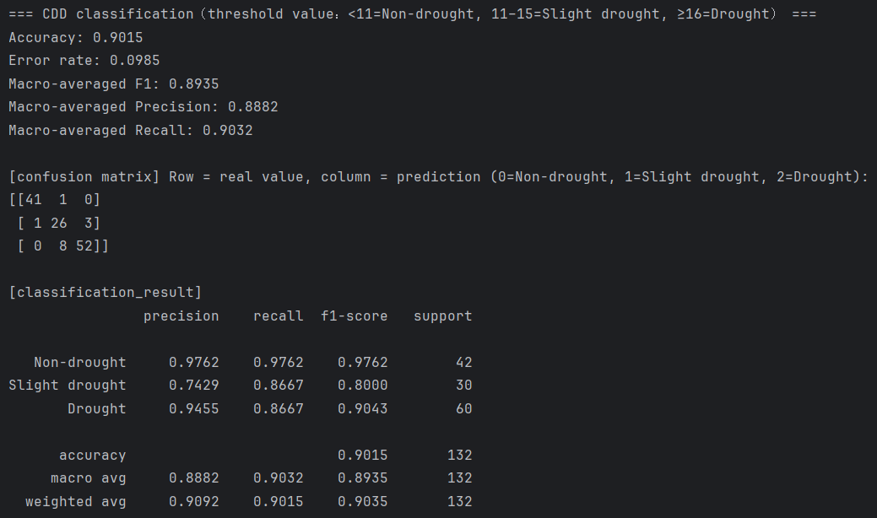
Figure 17 CEEMDAN-CNN-LSTM Classification Results (China Drought)
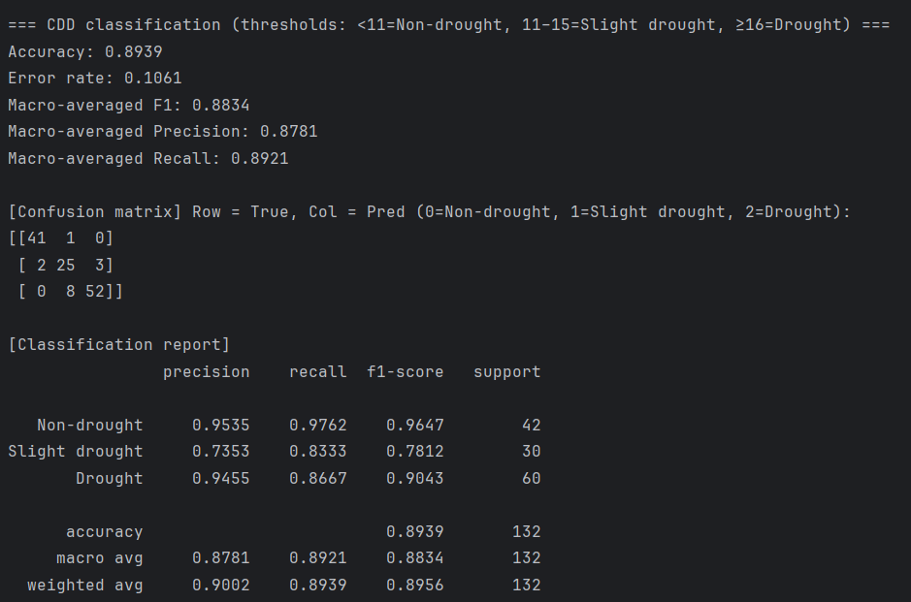
Figure 18 CEEMDAN-LSTM Classification Results (China Drought)
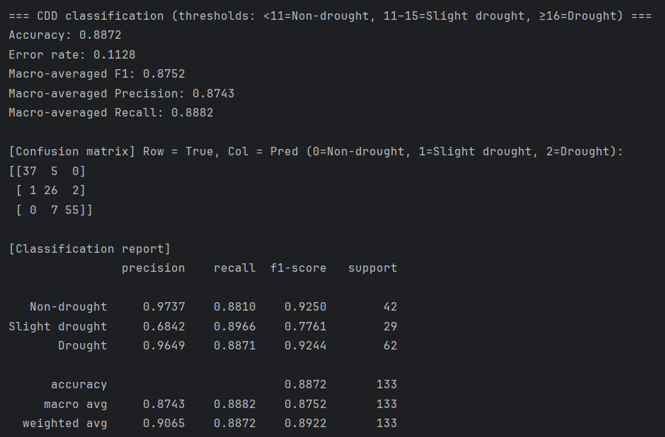
Figure 19 LSTM Classification Results (China Drought)
In the analysis of extreme rainfall, the performance of three models—LSTM, CEEMDAN-LSTM, and CEEMDAN-CNN-LSTM—was evaluated. Unlike CDD, which measures cumulative drought duration, rx5day captures the heaviest five consecutive days of rainfall within a month and is therefore more sudden and episodic in nature. The overall findings indicate that the CEEMDAN-LSTM model achieved improvements in five out of eight countries (China, India, Indonesia, Japan, and Vietnam), with the CEEMDAN-CNN-LSTM model performing best specifically in Indonesia. However, in Malaysia, the Philippines, and Thailand, neither hybrid model outperformed the standard LSTM.
For example, in China, the MAPE values for LSTM, CEEMDAN-LSTM, and CEEMDAN-CNN-LSTM were 14.04%, 13.98%, and 14.14%, respectively, with R² values around 94%. In Indonesia, the MAPE of the CEEMDAN-CNN-LSTM model dropped to 10.82%, outperforming the LSTM model's 11.75%. In contrast, in Malaysia and the Philippines—regions frequently affected by convective systems and typhoons—precipitation events are highly unpredictable. In these regions, the LSTM model generally performed better than the CEEMDAN-based models. For instance, in Malaysia, the MAPE increased to 20.24% and R² decreased to 16.21%, indicating a decline in model performance.
These results suggest that the integration of CEEMDAN and CNN can be beneficial when the signal is decomposable and local peak information is informative. Conversely, in regions where exogenous climatic factors introduce greater randomness into the target variable, incorporating climate-related exogenous variables may be necessary to further enhance model performance.
Table 3 Summary of Flood Prediction Results
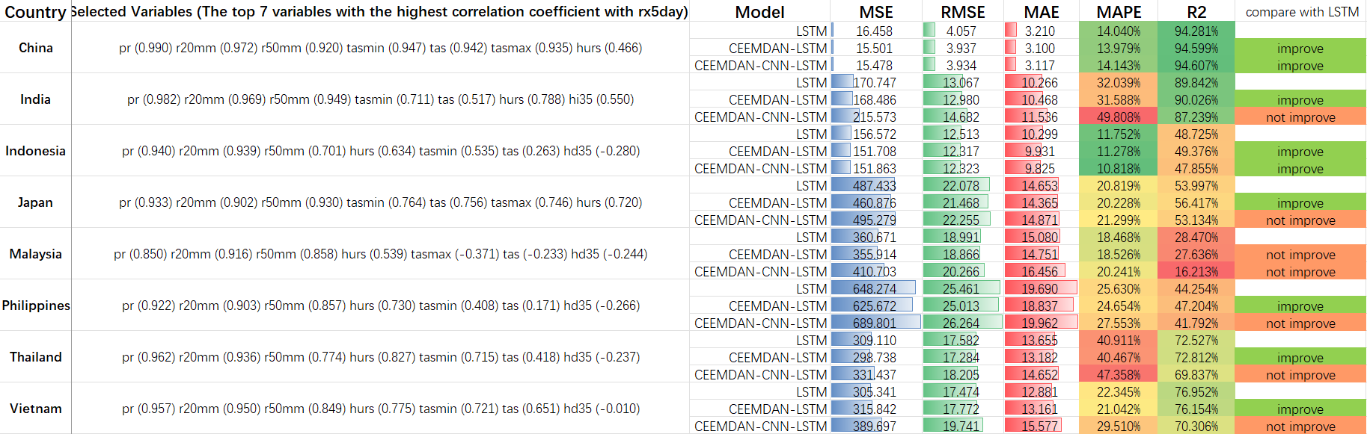
The CEEMDAN-LSTM model achieved the best performance, with an accuracy of 0.9621, a macro-F1 score of 0.9441, a slight flood recall of 0.8966, and a precision of 0.9286. This represents a significant improvement—approximately 6.9 percentage points—in recall for slight flood events compared to the LSTM baseline, which achieved a recall of 0.8276.
The CEEMDAN-CNN-LSTM model ranked second, achieving an accuracy of 0.9549, a macro-F1 score of 0.9321, and a slight flood recall of 0.8621. While it outperformed the baseline LSTM model, its performance was slightly lower than that of the CEEMDAN-LSTM model.
The baseline LSTM model achieved an accuracy of 0.9470, a macro-F1 score of 0.9196, and a slight flood recall of 0.8276. The primary limitation of this model was its tendency to misclassify slight flood events as non-flood events.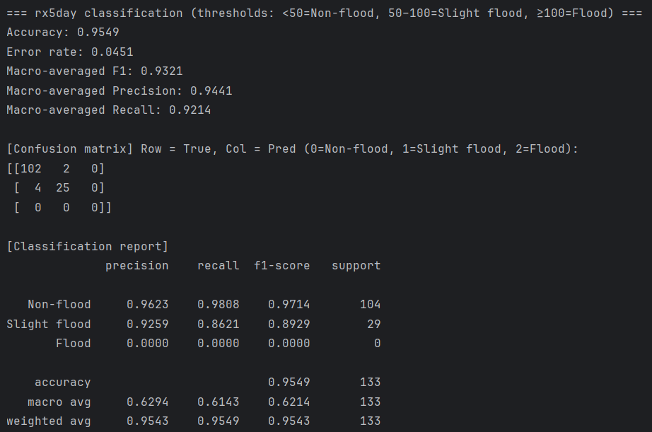
Figure 20 CEEMDAN-CNN-LSTM Classification Results (China Flood)
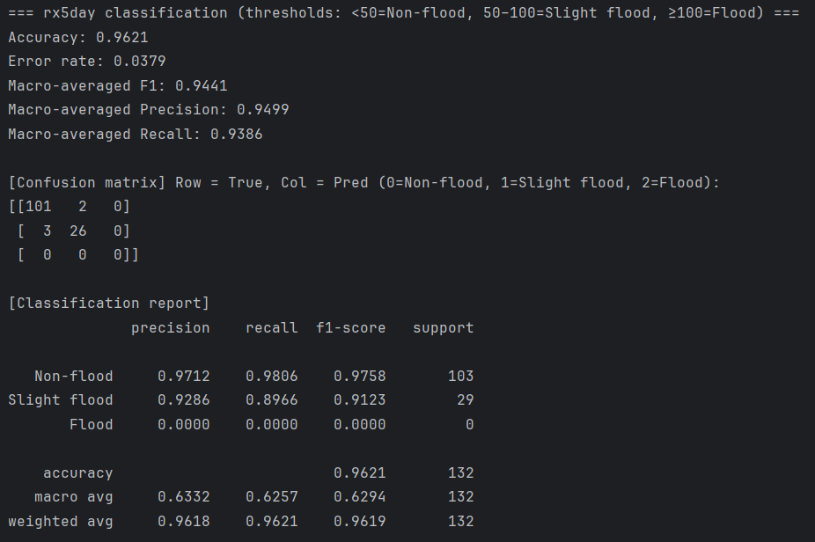
Figure 21 CEEMDAN-LSTM Classification Results (China Flood)
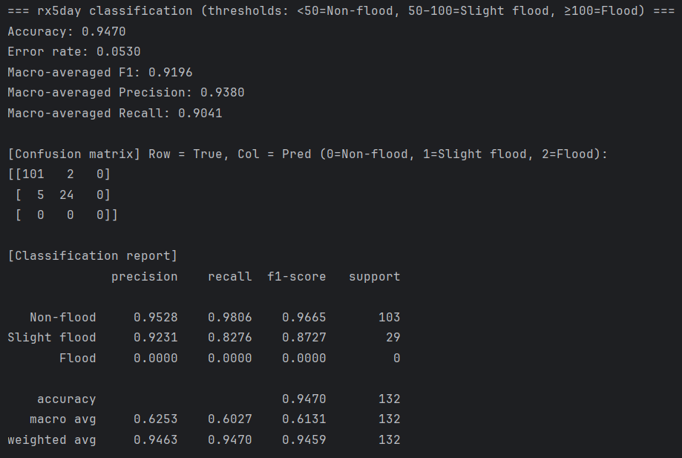
Figure 22 LSTM Classification Results (China Flood)
In Indonesia, both models combined with CEEMDAN outperformed LSTM. CEEMDAN-LSTM achieved the best overall performance, with accuracy (0.7348) and weighted-F1 (0.7274). CEEMDAN-CNN-LSTM showed significant gains in extreme class (Flood) recall, but was slightly inferior to CEEMDAN-LSTM overall, with accuracy (0.7218).
Insight
Model Architecture Adaptability
Experimental results demonstrate that CEEMDAN decomposition can generally improve the predictive capability of LSTM models, but it is not perfectly applicable to all extreme climate event prediction tasks. Model effectiveness primarily depends on geographical features and event types. CEEMDAN-based models perform better in monsoon climate regions such as China and India compared to tropical rainforest climate regions, indicating that CEEMDAN signal decomposition techniques are most effective when applied to climate systems with strong periodic components. Regarding climate event types, CEEMDAN-CNN-LSTM or CEEMDAN-LSTM models tend to have stronger predictive capabilities for cumulative process events such as consecutive droughts. However, extreme precipitation events characterized by suddenness show mixed results (CEEMDAN-LSTM improved in 5 out of 8 countries compared to LSTM, while CEEMDAN-CNN-LSTM improved in only 2 out of 8 countries).
This differentiated performance reflects the inherent physical mechanism differences of various climate events. Drought, as a slowly developing cumulative process, has time series data with stronger trend and periodic characteristics, allowing CEEMDAN decomposition to effectively extract these multi-scale features. In contrast, extreme precipitation events are often caused by rapidly changing weather systems such as convective systems and typhoons, whose randomness and suddenness make it difficult to fully leverage the advantages of signal decomposition.
Relationship Between Data Correlation Coefficient and Model Performance
Comparative analysis indicates that the strength of the correlation between meteorological variables and the target variable is a critical determinant of model performance. In regions with high correlation coefficients (e.g., China and India, where correlation coefficients exceed 0.75), CEEMDAN decomposition effectively extracts meaningful intrinsic mode functions (IMFs), thereby enhancing prediction accuracy. In contrast, in regions with weaker correlations (e.g., Japan and Malaysia, where correlation coefficients range between 0.44 and 0.75), the decomposed IMFs may introduce additional noise, which can degrade model performance.
For instance, in the case of drought prediction in Japan, the weak correlation between meteorological variables and CDD leads to the decomposition of signals with "white noise"-like characteristics by CEEMDAN, resulting in the generation of spurious modal components. Furthermore, since each IMF is modeled independently in the subsequent LSTM stage, large individual prediction errors can accumulate during the final summation, leading to error amplification. The decline in R² from -9.32% for the LSTM model to -72.81% for the CEEMDAN-CNN-LSTM model in Japan clearly illustrates this cumulative error effect.
Therefore, it is recommended that the correlation coefficient matrix between input features and the target variable be computed prior to applying CEEMDAN. Decomposition techniques should only be considered when the maximum correlation coefficient exceeds 0.70. For cases with moderate correlation, it may be more effective to use only the first few dominant IMF components rather than all decomposed components, in order to minimize the introduction of noise and improve model robustness.
Regional Variability Analysis
Experimental results reveal notable regional differences in predictive performance. The East Asian monsoon region (China) and the South Asian monsoon region (India) generally exhibit higher accuracy in predictions compared to maritime climate regions in Southeast Asia, such as Malaysia and the Philippines. This discrepancy can be primarily attributed to the following factors:
Climate System Complexity: Monsoon-dominated regions are characterized by relatively stable and predictable seasonal climate cycles. In contrast, maritime climate regions are influenced by multiple interacting climatic factors, including ENSO (El Niño–Southern Oscillation), IOD (Indian Ocean Dipole), and tropical cyclones, which collectively increase the complexity and uncertainty of climate predictions.
Topographic Effects: Island nations such as Indonesia and the Philippines feature complex topography, including mountainous terrain and fragmented landforms. These geographical features amplify local climate variability and atmospheric instability, thereby reducing the effectiveness of regional-scale climate prediction models.
PRACTICAL VALUE
The findings of this study provide valuable guidance for climate risk management practices. In practical applications, prediction strategies should be tailored to regional climate characteristics and event types, rather than adopting a one-size-fits-all modeling approach. With regard to early warning system design, the results suggest that cumulative climate events such as droughts are particularly well-suited for the CEEMDAN-LSTM model. This is because such events exhibit strong periodicity and trend characteristics, which allow decomposition techniques to effectively extract multi-scale information.
In contrast, for sudden precipitation events—especially in tropical maritime climate regions—complex hybrid models should be applied with caution. Precipitation patterns in these areas are influenced by multiple stochastic factors, and forced decomposition may introduce noise, thereby degrading model performance.
From the perspective of computational resource allocation, the study highlights an important practical insight: in regions with weak data correlation, simpler LSTM models may actually offer a better cost-benefit trade-off. This finding is particularly relevant for meteorological agencies with limited resources, as it demonstrates that computationally intensive models are not always necessary. Decision-makers should first evaluate the quality and correlation structure of local meteorological data before selecting an appropriately complex model. This approach ensures prediction accuracy while avoiding unnecessary computational overhead.
LIMITATIONS AND FUTURE DIRECTIONS
Although this study has made meaningful progress in the prediction of extreme climate events, several limitations remain that warrant further investigation. First, the current models primarily rely on historical meteorological observations and do not adequately incorporate large-scale climate oscillation systems—such as the El Niño–Southern Oscillation (ENSO) and the Indian Ocean Dipole (IOD)—as exogenous variables. These climate modes exert significant influence on regional extreme events. Future research should explore effective methods for integrating these external signals, potentially through multi-source data fusion techniques or the design of specialized feature extraction modules.
A second limitation lies in the insufficient utilization of spatial information. Current model architectures predominantly focus on temporal modeling, neglecting the spatial propagation and interaction patterns of extreme climate events. These events often exhibit strong spatial correlations and teleconnection behaviors, and overlooking such relationships may result in the loss of valuable predictive information. Incorporating graph neural networks or spatial attention mechanisms could offer a promising solution, as these approaches are capable of jointly modeling spatiotemporal dependencies and are expected to enhance overall prediction performance.
Regarding computational efficiency, while CEEMDAN decomposition improves prediction accuracy, it introduces considerable computational overhead—particularly in operational forecasting systems that require real-time updates. Each IMF component necessitates the training of a separate model, which increases both training time and the complexity of model deployment and maintenance. Future work should focus on developing more efficient signal decomposition algorithms or implementing parallel computing strategies to accelerate the decomposition and training processes, thereby enhancing the practical applicability of this method.
Moreover, the current model framework generates deterministic point predictions without providing a quantitative assessment of prediction uncertainty. In climate risk management, understanding prediction confidence intervals is often as critical as the predicted values themselves. Incorporating Bayesian deep learning techniques or constructing ensemble prediction systems could enable probabilistic forecasting, allowing decision-makers to better assess risks and formulate appropriate mitigation strategies.
Finally, this study primarily validated the model’s short-term prediction capabilities, whereas many real-world applications demand seasonal or even interannual forecasts. The model’s performance in long-term prediction tasks and its tendency to degrade over extended time horizons require systematic evaluation and improvement.
In summary, the CEEMDAN-CNN-LSTM hybrid model offers a promising technical framework for predicting extreme climate events. However, its successful application depends on adaptive adjustments tailored to specific geographical environments, climate characteristics, and event types. Future research should aim to develop more intelligent and adaptive model selection mechanisms that can automatically determine optimal architectures and parameter configurations based on the statistical properties of input data, ultimately advancing the development of truly intelligent climate prediction systems.
REFERENCE LIST
Intergovernmental Panel on Climate Change (IPCC). (2023). Climate change 2023: Synthesis report – Summary for policymakers. https://www.ipcc.ch/report/sixth-assessment-report-synthesis-report/
Muhammad, M. K. I., Hamed, M. M., Harun, S., & Mohd, N. (2024). Heatwaves in Peninsular Malaysia: A spatiotemporal analysis. Scientific Reports, 14, 4255. https://doi.org/10.1038/s41598-024-42911-1
World Meteorological Organization (WMO). (2022, November 11). Economic losses from extreme weather rocket in Asia. https://public.wmo.int/en/media/press-release/economic-losses-extreme-weather-rocket-asia-wmo
World Bank. (2021). Climate risk country profile: Malaysia. https://climateknowledgeportal.worldbank.org/country/malaysia/climate-data-projections
Zhang, H., Liu, Y., Zhang, C., & Li, N. (2025). Machine learning methods for weather forecasting: A survey. Atmosphere, 16(1), 82.
Camps-Valls, G., Fernández-Torres, M. Á., Cohrs, K. H., Höhl, A., Castelletti, A., Pacal, A., … Williams, T. (2025). Artificial intelligence for modeling and understanding extreme weather and climate events. Nature Communications, 16, 1919. https://doi.org/10.1038/s41467-025-56573-8
World Meteorological Organization (WMO). (2024, April 23). Climate change and extreme weather impacts hit Asia hard [Press release]. https://public.wmo.int/en/media-centre/press-release/climate-change-and-extreme-weather-impacts-hit-asia-hard
Verma, S., Srivastava, K., Tiwari, A., & Verma, S. (2023). Deep learning techniques in extreme weather events: A review. arXiv preprint arXiv:2308.10995. https://arxiv.org/abs/2308.10995
Islam, T., Mazumder, T., Roni, M. N. S., & Nur, M. S. (2024). A comparative study of machine learning models for predicting Aman rice yields in Bangladesh. Heliyon, 10(23), e40764. https://doi.org/10.1016/j.heliyon.2024.e40764
Kumar, V., Kedam, N., Sharma, K. V., Khedher, K. M., & Alluqmani, A. E. (2023). A comparison of machine learning models for predicting rainfall in urban metropolitan cities. Sustainability, 15(18), 13724. https://doi.org/10.3390/su151813724
Wang, T., Tu, X., Singh, V. P., Chen, X., Lin, K., & Zhou, Z. (2023). Drought prediction: Insights from the fusion of LSTM and multi-source factors. Science of The Total Environment, 902, 166361. https://doi.org/10.1016/j.scitotenv.2023.166361
Zhang, R., Chen, Z.-Y., Xu, L.-J., & Ou, C.-Q. (2019). Meteorological drought forecasting based on a statistical model with machine learning techniques in Shaanxi province, China. Science of The Total Environment, 665, 338–352. https://doi.org/10.1016/j.scitotenv.2019.01.431
Li, J., Wu, G., Zhang, Y., & Shi, W. (2024). Optimizing flood predictions by integrating LSTM and physical-based models with mixed historical and simulated data. Heliyon, 10(13), e33669. https://doi.org/10.1016/j.heliyon.2024.e33669
Shafiq, F., Zafar, A., Khan, M. U. G., Iqbal, S., Albesher, A. S., & Asghar, M. N. (2025). Extreme heat prediction through deep learning and explainable AI. PLOS ONE, 20(3), e0316367. https://doi.org/10.1371/journal.pone.0316367
Essa, Y., Hunt, H. G. P., Gijben, M., & Ajoodha, R. (2022). Deep learning prediction of thunderstorm severity using remote sensing weather data. IEEE Journal of Selected Topics in Applied Earth Observations and Remote Sensing, 15, 4004–4013. https://doi.org/10.1109/JSTARS.2022.3172785
Dikshit, A., Pradhan, B., & Huete, A. (2021). An improved SPEI drought forecasting approach using the long short-term memory neural network. Journal of Environmental Management, 283, 111979. https://doi.org/10.1016/j.jenvman.2021.111979
Xie, T., Liu, C., Hu, C., Li, W., & Li, R. (2024). Study on long short-term memory based on vector direction of flood process for flood forecasting. Scientific Reports, 14, 21446. https://doi.org/10.1038/s41598-024-72205-5
Frifra, A., Maanan, M., Maanan, M., & Rhinane, H. (2024). Harnessing LSTM and XGBoost algorithms for storm prediction. Scientific Reports, 14, 11381. https://doi.org/10.1038/s41598-024-62182-0
Huang, N. E., Shen, Z., Long, S. R., Wu, M. C., Shih, H. H., Zheng, Q., ... & Liu, H. H. (1998). The empirical mode decomposition and the Hilbert spectrum for nonlinear and non-stationary time series analysis. Proceedings of the Royal Society of London. Series A: Mathematical, Physical and Engineering Sciences, 454(1971), 903–9095. https://doi.org/10.1098/rspa.1998.0193
Torres, M. E., Colominas, M. A., Schlotthauer, G., & Flandrin, P. (2011, May). A complete ensemble empirical mode decomposition with adaptive noise. In 2011 IEEE International Conference on Acoustics, Speech and Signal Processing (ICASSP) (pp. 4144–4147). IEEE. https://doi.org/10.1109/ICASSP.2011.5947265
Wu, Z., & Huang, N. E. (2009). Ensemble empirical mode decomposition: A noise-assisted data analysis method. Advances in Adaptive Data Analysis, 1(01), 1–41. https://doi.org/10.1142/S1793536909000047

